__________ Program Review

Author

Fall 2019

Table of Contents

# BACKGROUND

## Program Mission Statement

From Unit Plan…

## Program Description

From Unit Plan…

## Previous Rrogram Review Recommendations

Response…

## Previous Unit Plans

Provide an executive summary of unit plans since last Program Review. Briefly list major accomplishments and ongoing challenges relative to: a. assessment and improvement of student learning b. student success, persistence and completion c. other department goals

###### page break

# CURRENT STATUS

## Butte College Mission Support

Explain how courses in this program support the college’s mission. Emphasize the program’s role in the institutional commitment to student learning.

## Situation Analysis

Explain developments since the last Program Review that may affect the program’s ability to support student learning through the services that it offers.

## Data Analysis

This section contains program overview data. Further programatic data can be found in Appendix XX and may be coppied to this section should to provide furter information on the program. Discuss the significance of results and indicate trends (if possible). Contact the Department of Institutional Effectiveness if you would like additional data or insight.

### Headcount and Enrollment

This section shows student headcount (unduplicated) and enrollment (duplicated) by program, department, and term. Information at the course level is available in the Data Appendix.

#### Headcount

Is program headcount moving in the same direction as the college? Is there growth?

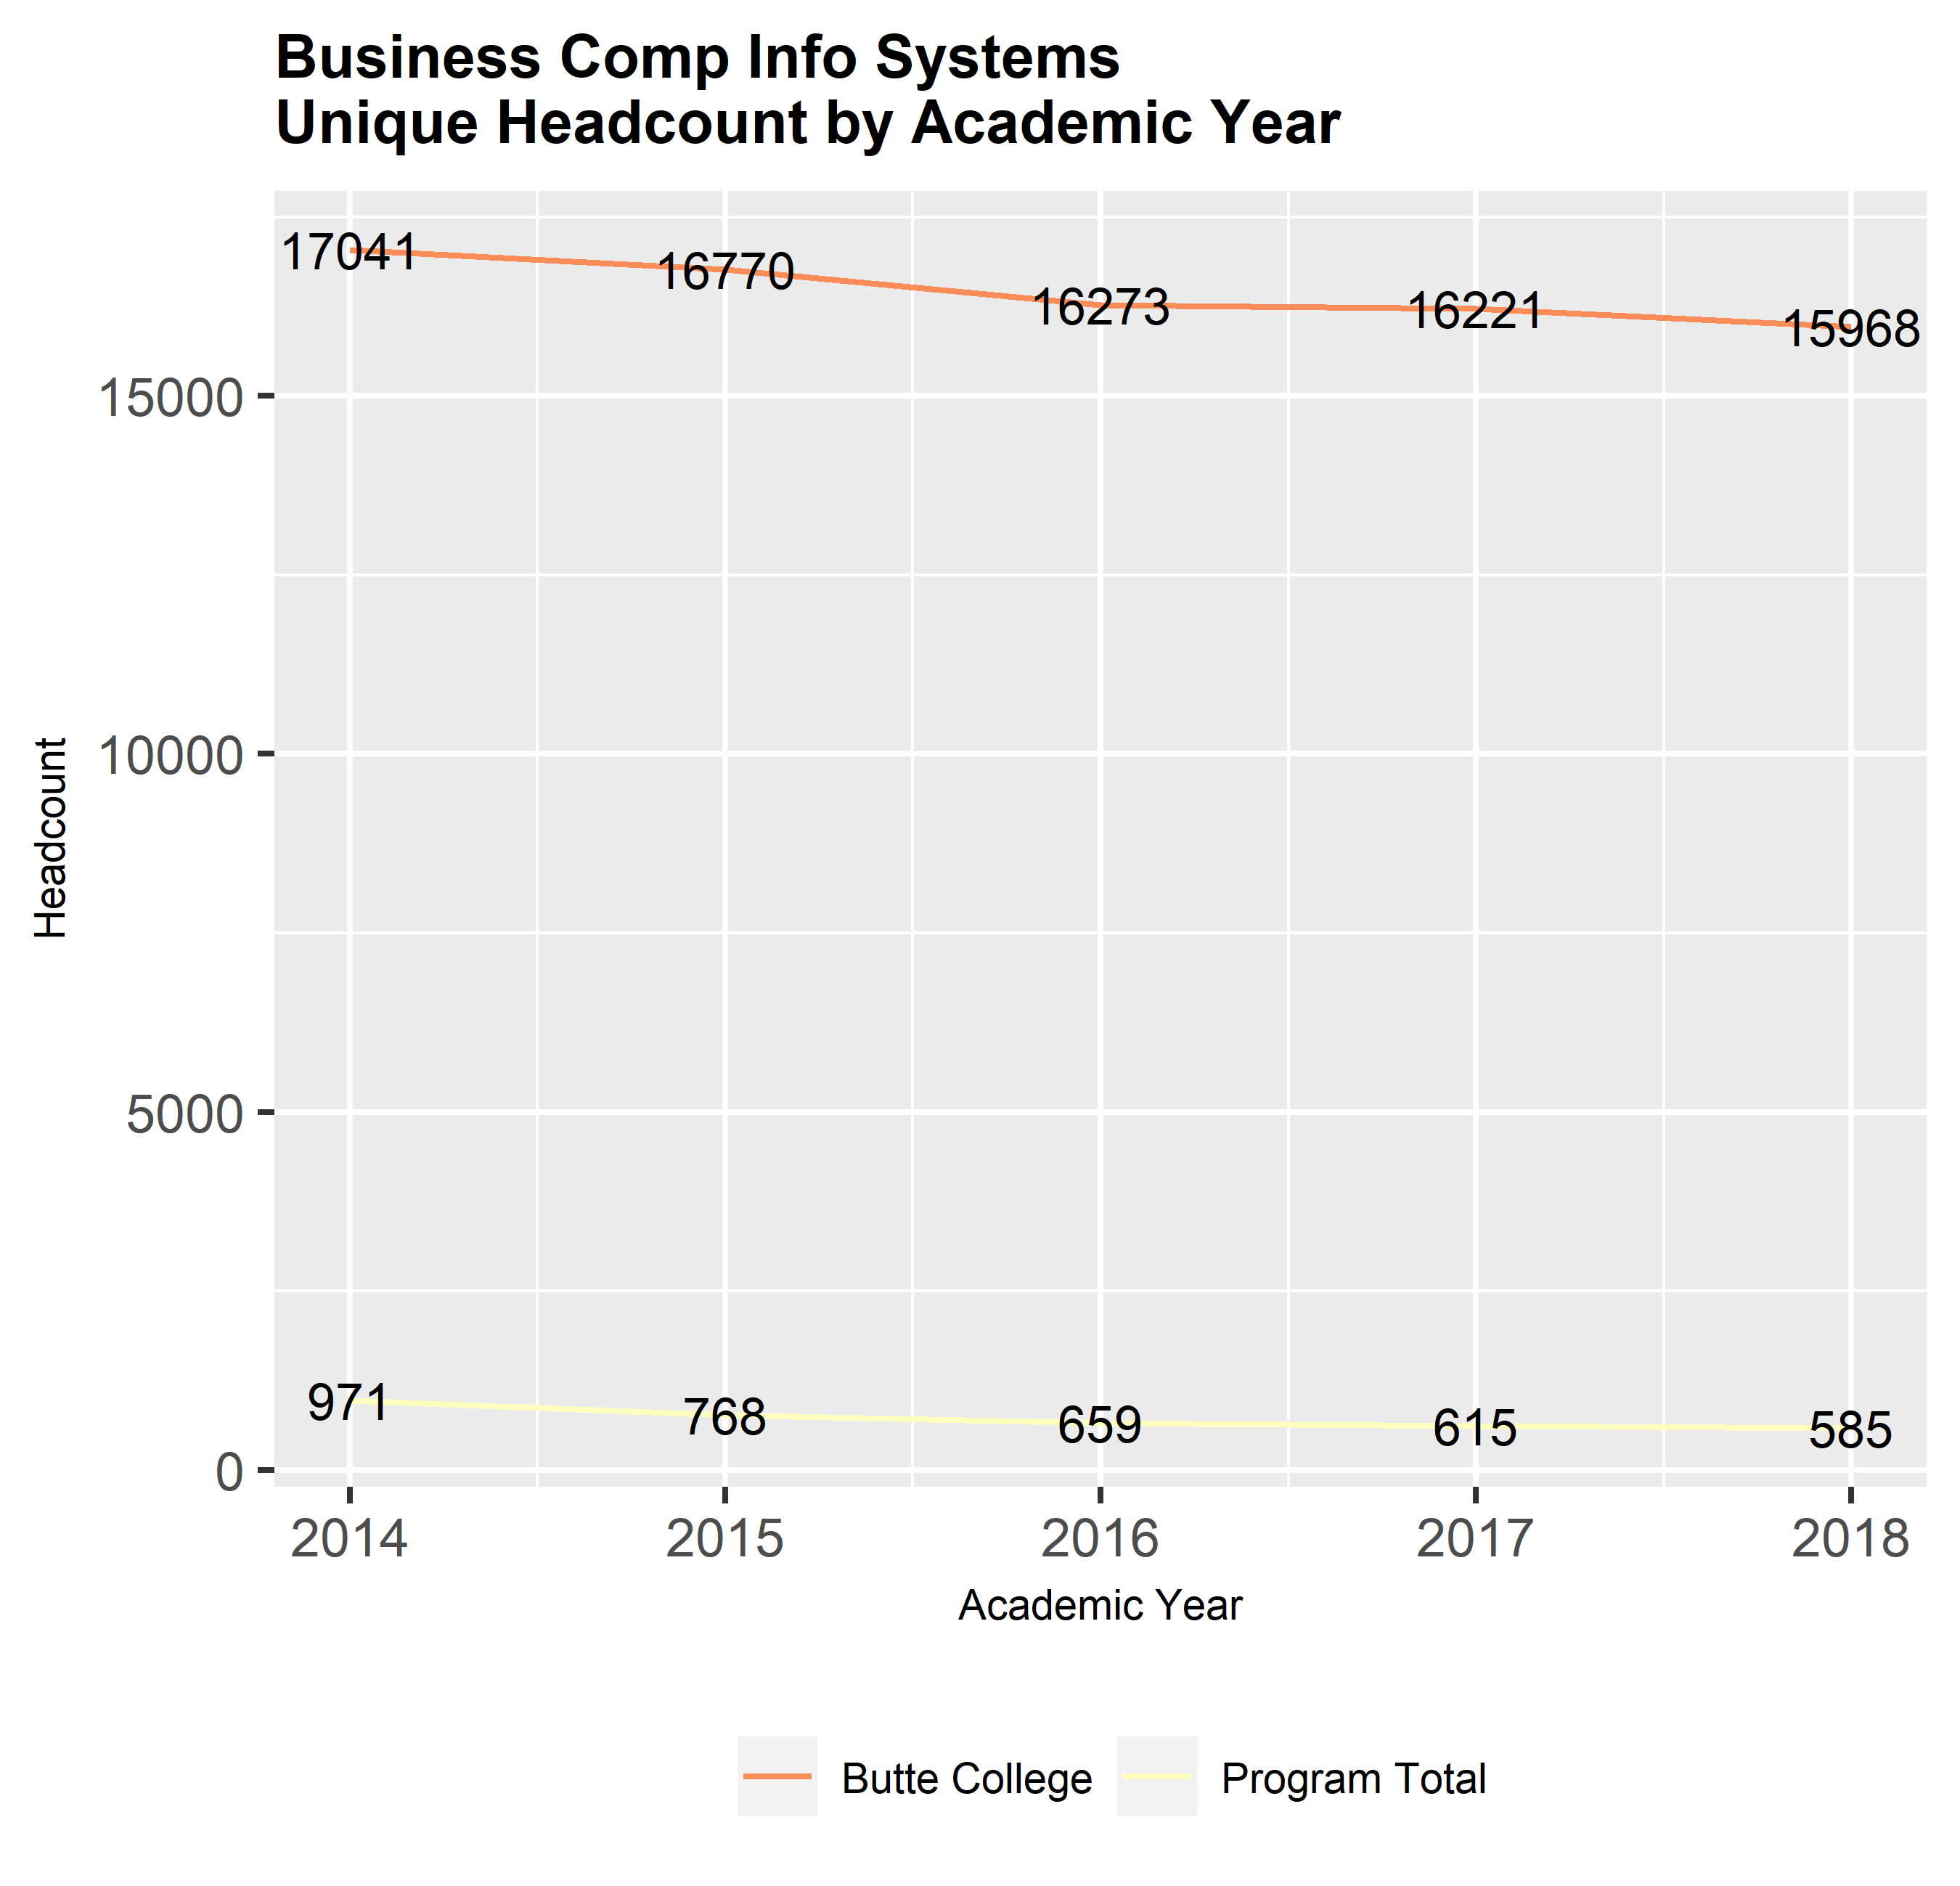

#### Enrollment

Are department enrollments changing? Why?

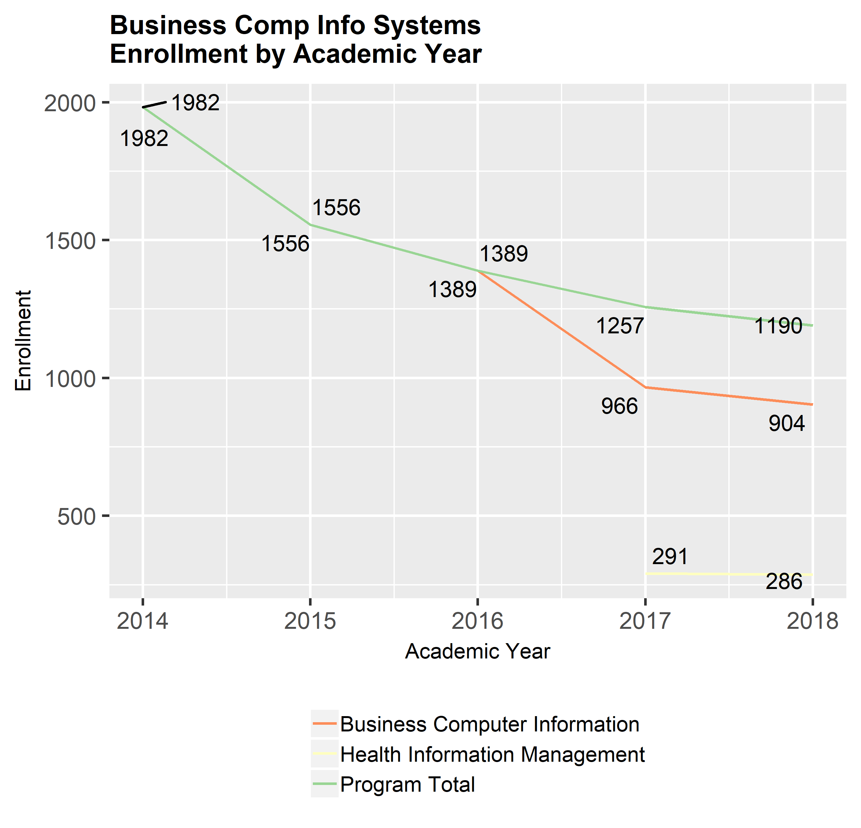

#### Enrollment by Department and Term

Are department ernollments changing on a term basis? Is one term significantly larger than another?

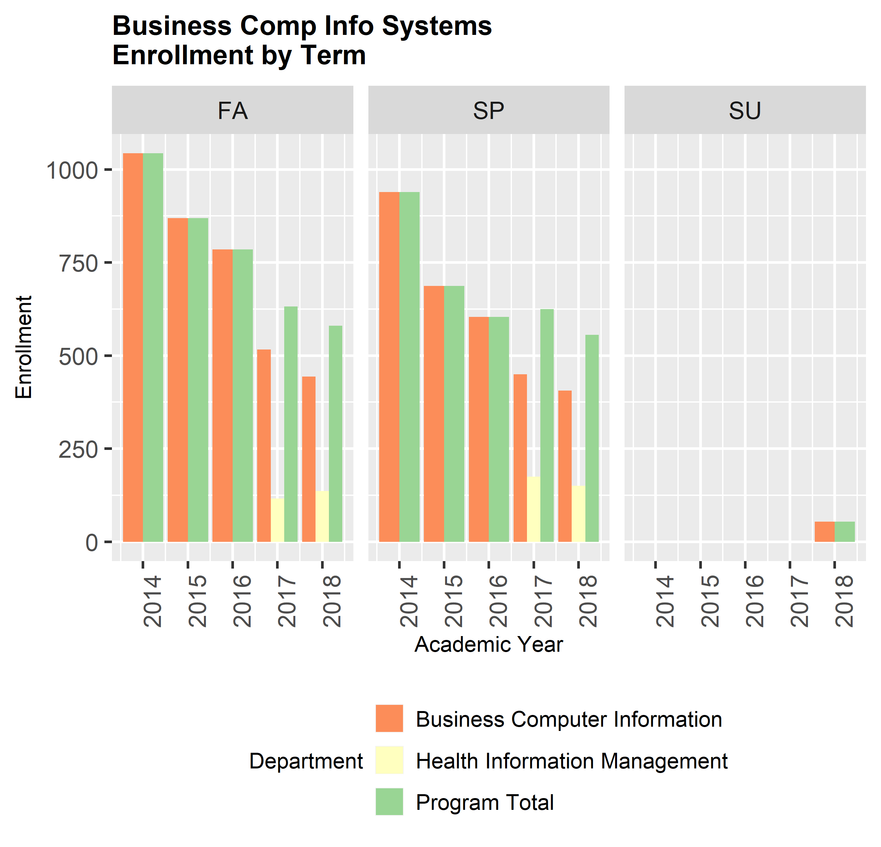

### Student Majors

Butte College is revamping processes to reflect the guided pathways initiative and program thiniking. To that end information is included in program review to evaluate the number of students in a particular major and information on how students migrate between majors.

#### Number of Current Students with Majors in the Program

This chart shows the number of students who were actively enrolled in the prior fall who had a major in the program, regardless of the classes the student actually took in the fall. A student who has multiple majors will be catagorized by their most recent selection and a student who is seeking certificates and a degree will be catagorized by the degree. Do program course offerings reflect the number of students majoring in the program?

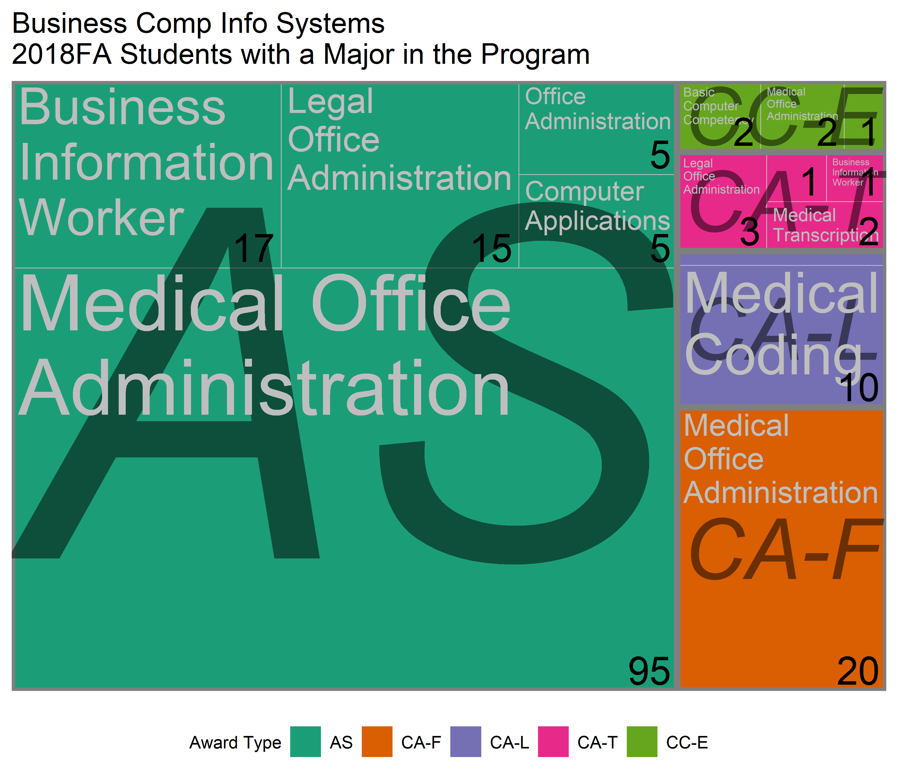

#### Major Flow In

The following tables show relative flow of students into and out of majors within the program. These tables show the student’s first major and their eventual earned award. To be included, the student must have earned an award within the last year.

|  |  |  |
| --- | --- | --- |
| FIRST_PROGRAM | END_PROGRAM | COMPLETERS |
| Business Comp Info Systems | Business Comp Info Systems | 69 |
| Business Education | Business Comp Info Systems | 47 |
| Biology | Business Comp Info Systems | 8 |
| Admin of Justice & Fire Tech | Business Comp Info Systems | 5 |
| Arts | Business Comp Info Systems | 3 |
| Food & Nutrition | Business Comp Info Systems | 3 |
| Respiratory Care | Business Comp Info Systems | 3 |
| Cmptr Sci Design/Sustain Tech | Business Comp Info Systems | 2 |
| Social & Behavioral Sciences | Business Comp Info Systems | 2 |
| Agriculture | Business Comp Info Systems | 1 |
| Emergency Med Services | Business Comp Info Systems | 1 |
| Health, Kinesiology, Athletics | Business Comp Info Systems | 1 |
| Nursing Programs | Business Comp Info Systems | 1 |

#### Major Flow Out

This table shows the number of students who flowed out of the program. Aggregated students shown here had an original program of study within the program and earned an award - degree or certificate - in another program.

|  |  |  |
| --- | --- | --- |
| FIRST_PROGRAM | END_PROGRAM | LEAVERS |
| Business Comp Info Systems | Social & Behavioral Sciences | 10 |
| Business Comp Info Systems | Cmptr Sci Design/Sustain Tech | 8 |
| Business Comp Info Systems | Admin of Justice & Fire Tech | 7 |
| Business Comp Info Systems | Nursing Programs | 4 |
| Business Comp Info Systems | Emergency Med Services | 3 |
| Business Comp Info Systems | Support, Human Services | 2 |
| Business Comp Info Systems | Agriculture | 1 |
| Business Comp Info Systems | Arts | 1 |
| Business Comp Info Systems | Automotive Technology | 1 |
| Business Comp Info Systems | Business Education | 1 |
| Business Comp Info Systems | English & Journalism | 1 |
| Business Comp Info Systems | Language Ed & Development | 1 |
| Business Comp Info Systems | Public Safety Ed & Train Ctr | 1 |

###### page break

### Student Demographic Profile

Student demographic profile compared to the overall college profile to include gender, age, GPA, ethnicity, DSPS, Foster Youth, Veterans, and Economically Disadvantaged. When examining results, compare proportions of populations in your program with the college as a whole. Are there notworthy differences between the college and your program? This could indicate an access issue?

#### Student Gender

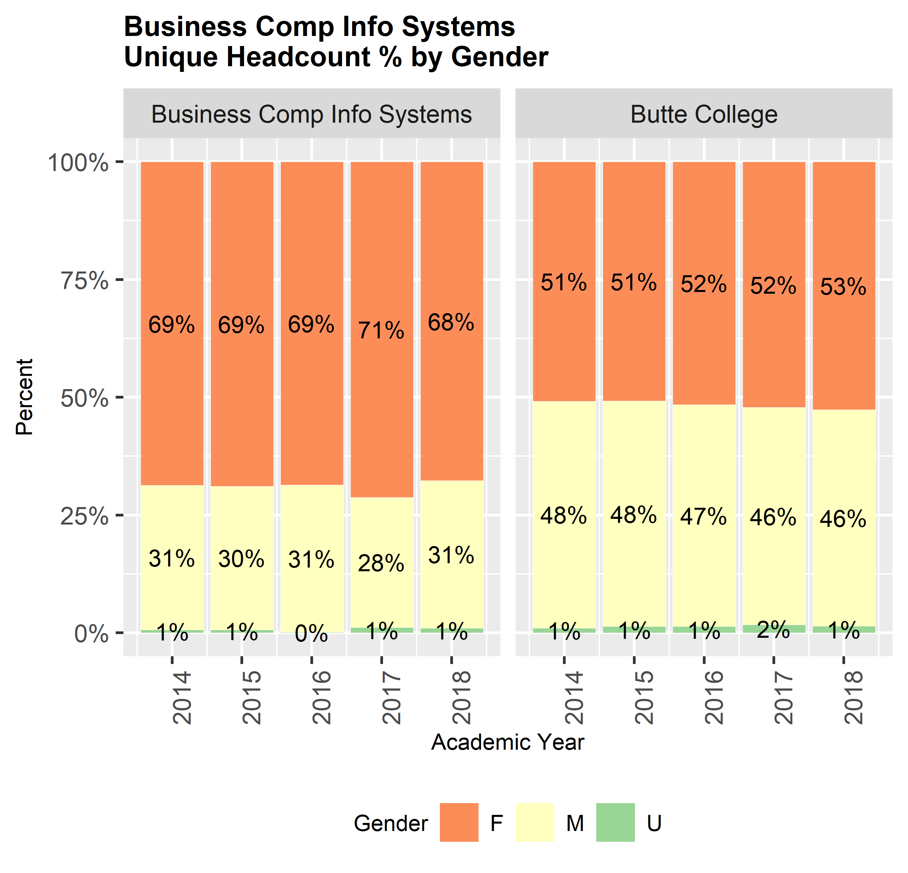

#### Student Age

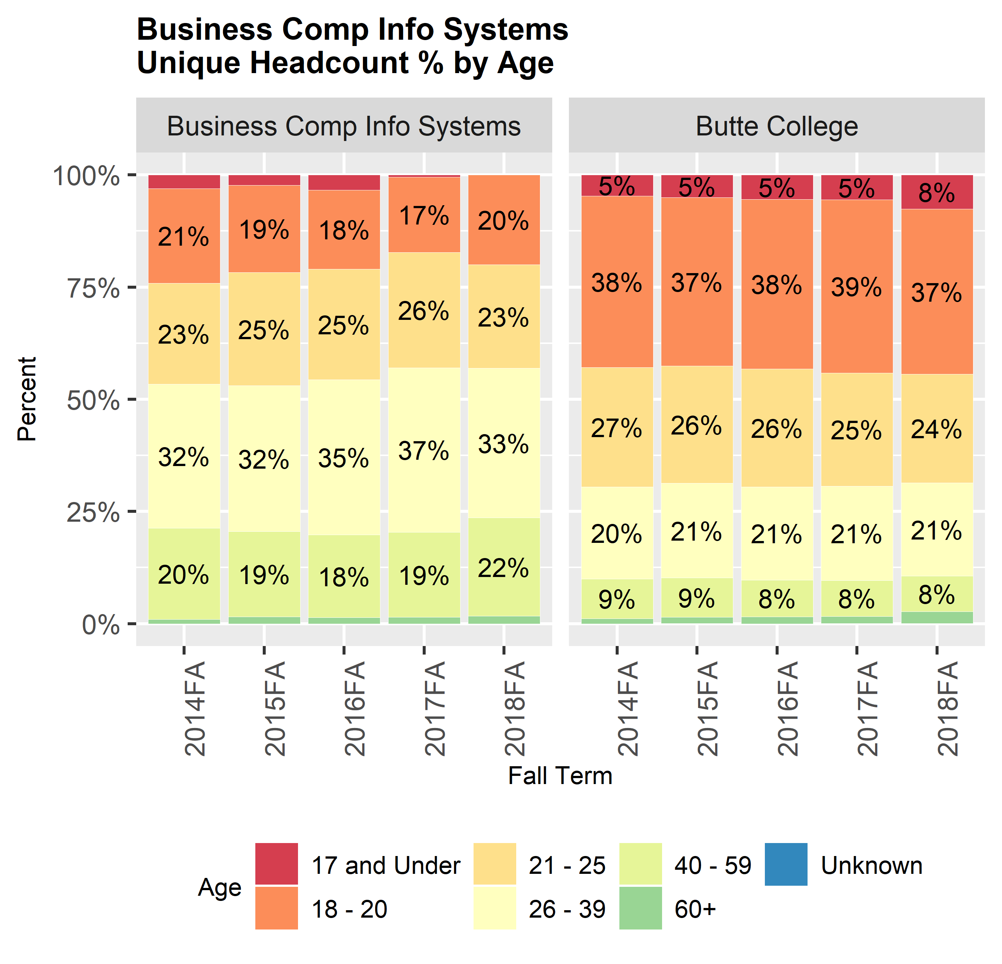

#### Student Ethnicity

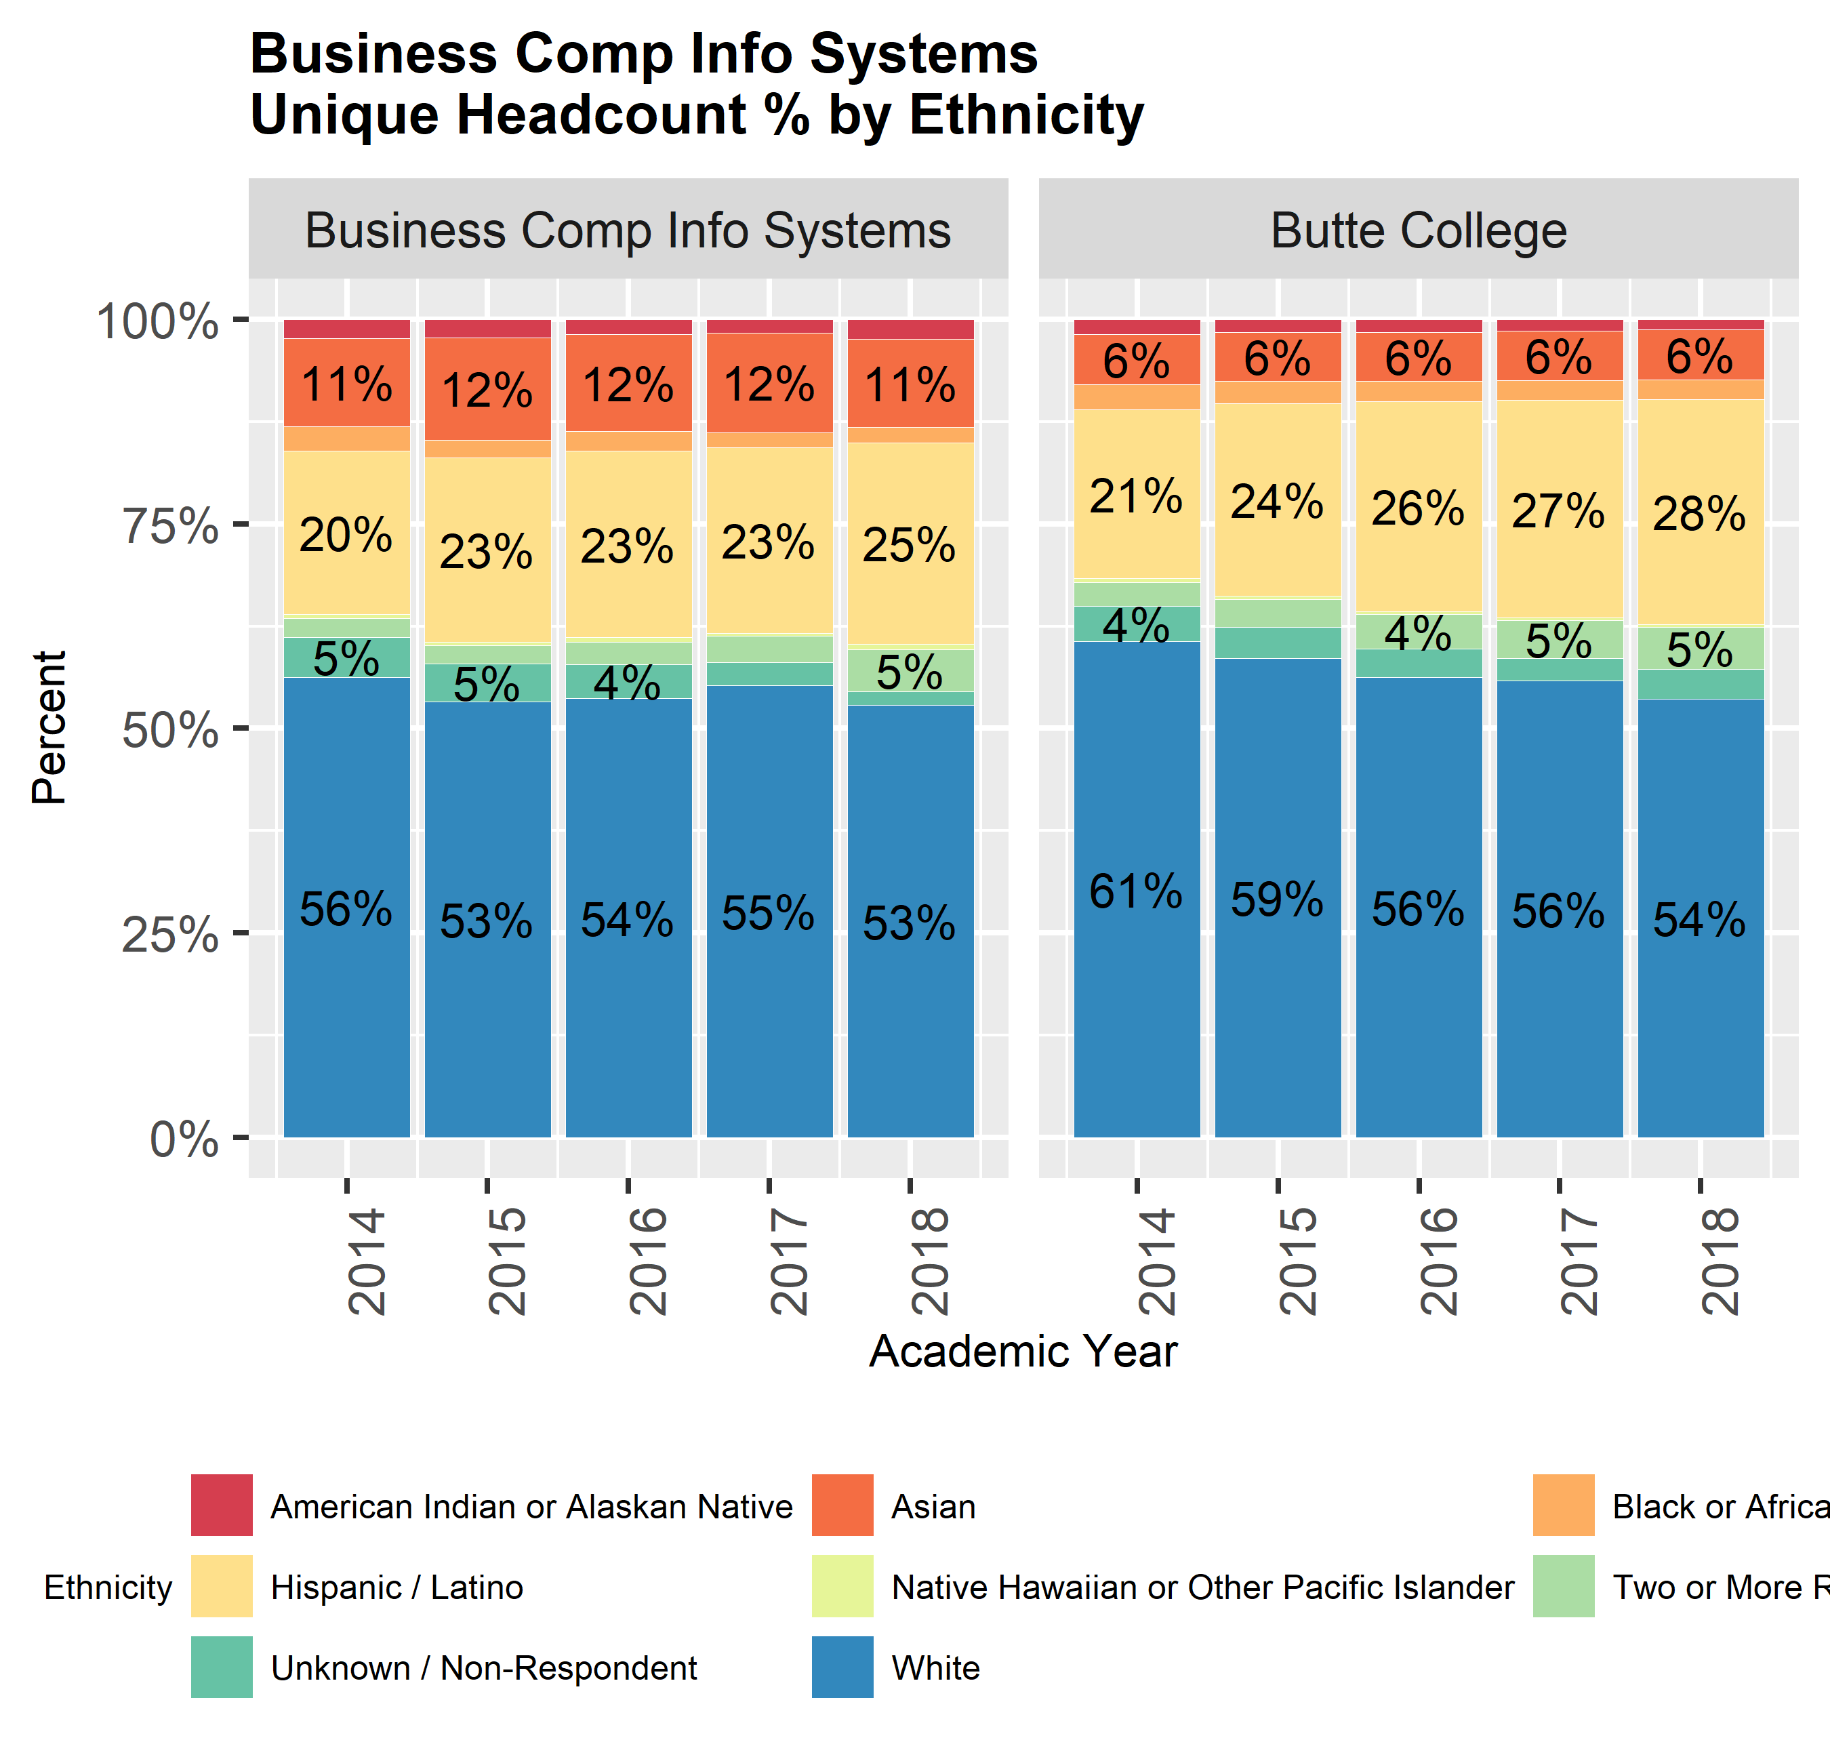

#### Student Income Status

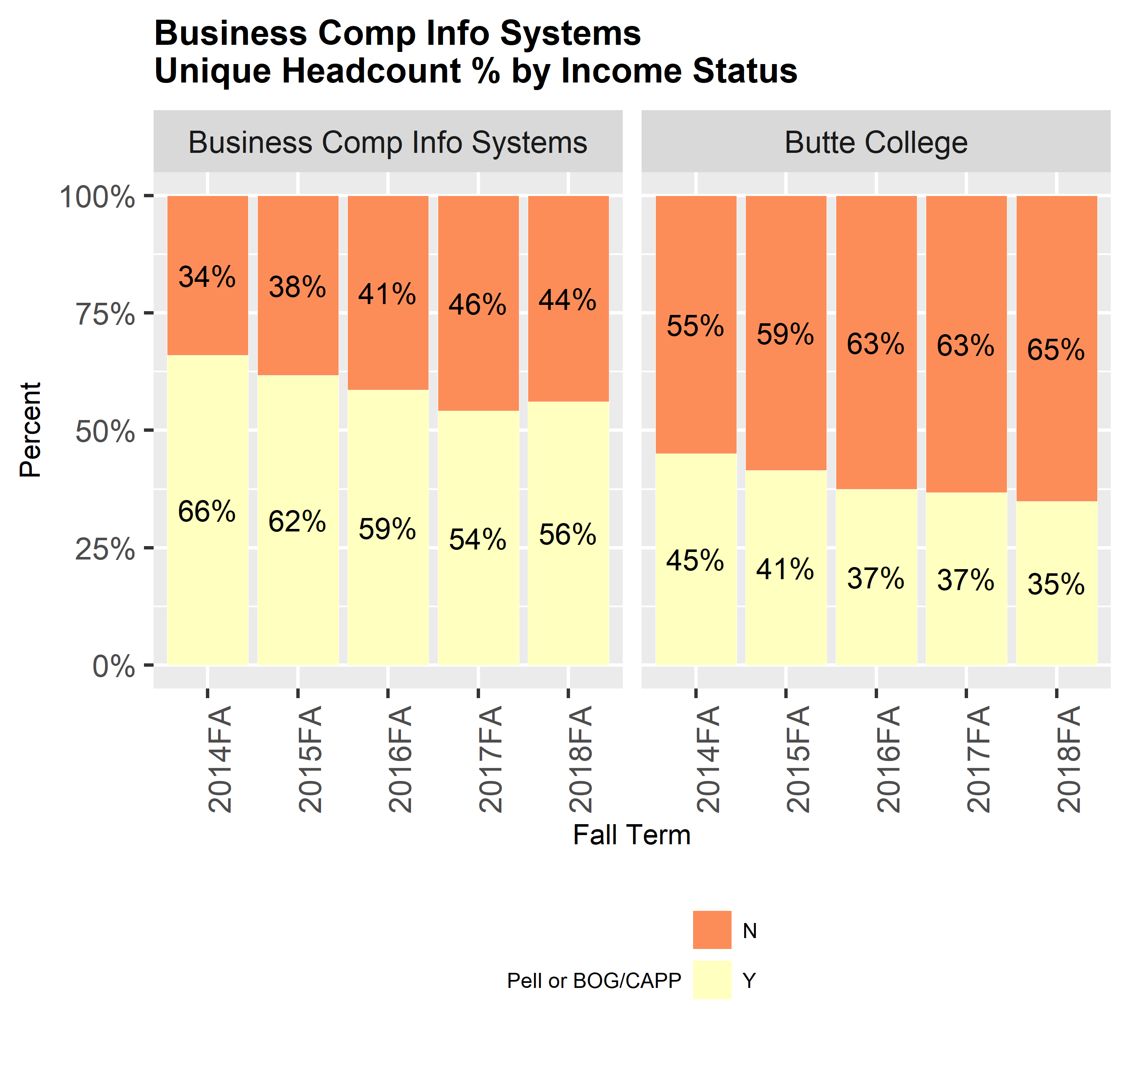

#### Special Populations

The percentage of program students in special populations groups averaged over the five year time-frame.

|  |  |  |  |
| --- | --- | --- | --- |
| Program | Identified as DSPS | Identified as Foster Youth | Identified as Veterans |
| Business Comp Info Systems | 11.4% | 3.5% | 3.4% |
| Butte College | 5.9% | 3.2% | 3.3% |

###### page break

### Program Capacity

Number of sections offered, enrollments, and fill rates by mode for the previous academic year. This data is available at the course level and over time in the data appendix.

|  |  |  |  |  |  |
| --- | --- | --- | --- | --- | --- |
| Dept | Loc | Mode | Sec_2018 | Enrl_2018 | FR_2018 |
| Business Comp Info Systems | Chico Center | F2F | 19 | 279 | 0.47 |
| Business Comp Info Systems | Chico Center | HYB | 1 | 18 | 0.51 |
| Business Comp Info Systems | Main Campus | F2F | 22 | 313 | 0.56 |
| Business Comp Info Systems | Main Campus | HYB | 8 | 147 | 0.60 |
| Business Comp Info Systems | Main Campus | NET | 16 | 426 | 0.77 |
| Butte College | Chico Center | F2F | 524 | 13096 | 0.75 |
| Butte College | Chico Center | HYB | 4 | 74 | 0.57 |
| Butte College | Main Campus | F2F | 1901 | 47745 | 0.62 |
| Butte College | Main Campus | HYB | 24 | 599 | 0.77 |
| Butte College | Main Campus | NET | 346 | 9443 | 0.81 |

#### Program Efficiency

Department/program FTES and efficiency (FTES/FTEF) by mode. This data is available at the course level in the data appendix.

|  |  |  |  |  |  |
| --- | --- | --- | --- | --- | --- |
| Dept | Loc | Mode | FTES_2018 | FTEF_2018 | Effcy_2018 |
| Business Comp Info Systems | Chico Center | F2F | 24.62 | 1.56 | 15.80 |
| Business Comp Info Systems | Chico Center | HYB | 2.40 | 0.12 | 19.54 |
| Business Comp Info Systems | Main Campus | F2F | 30.28 | 1.68 | 18.05 |
| Business Comp Info Systems | Main Campus | HYB | 20.30 | 1.03 | 19.75 |
| Business Comp Info Systems | Main Campus | NET | 30.27 | 1.13 | 26.71 |
| Butte College | Chico Center | F2F | 1379.71 | 57.01 | 24.20 |
| Butte College | Chico Center | HYB | 8.00 | 0.46 | 17.54 |
| Butte College | Main Campus | F2F | 5942.19 | 237.05 | 25.07 |
| Butte College | Main Campus | HYB | 69.43 | 2.73 | 25.45 |
| Butte College | Main Campus | NET | 943.97 | 35.04 | 26.94 |

### Program Success

Grade distribution, number of degrees and certificates awarded by type, ethnicity, DSPS, Foster Youth, Veterans, and Economically Disadvantaged (Part C)

#### Grade Distribution

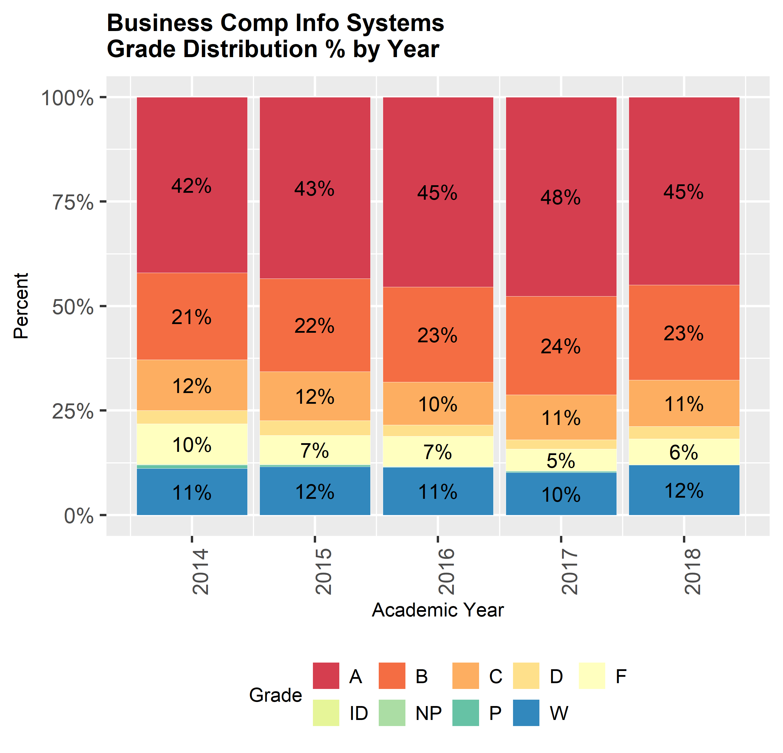

#### Department Grade Distribution

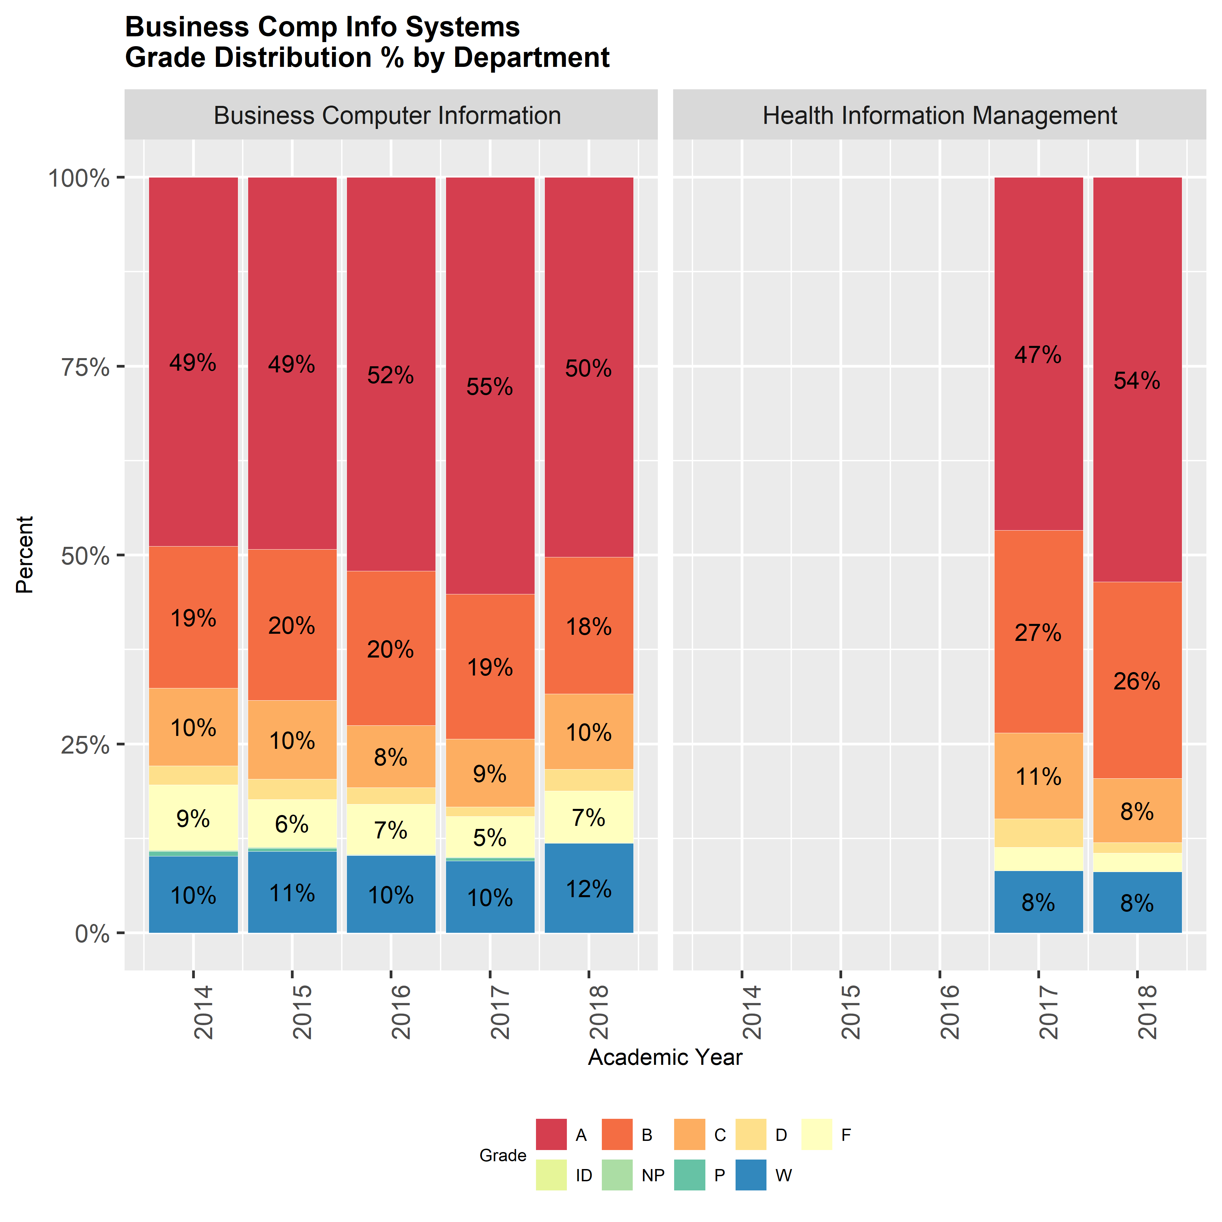

### Grade Distribution by Student Demographics

#### Grade Distribution by Student Gender

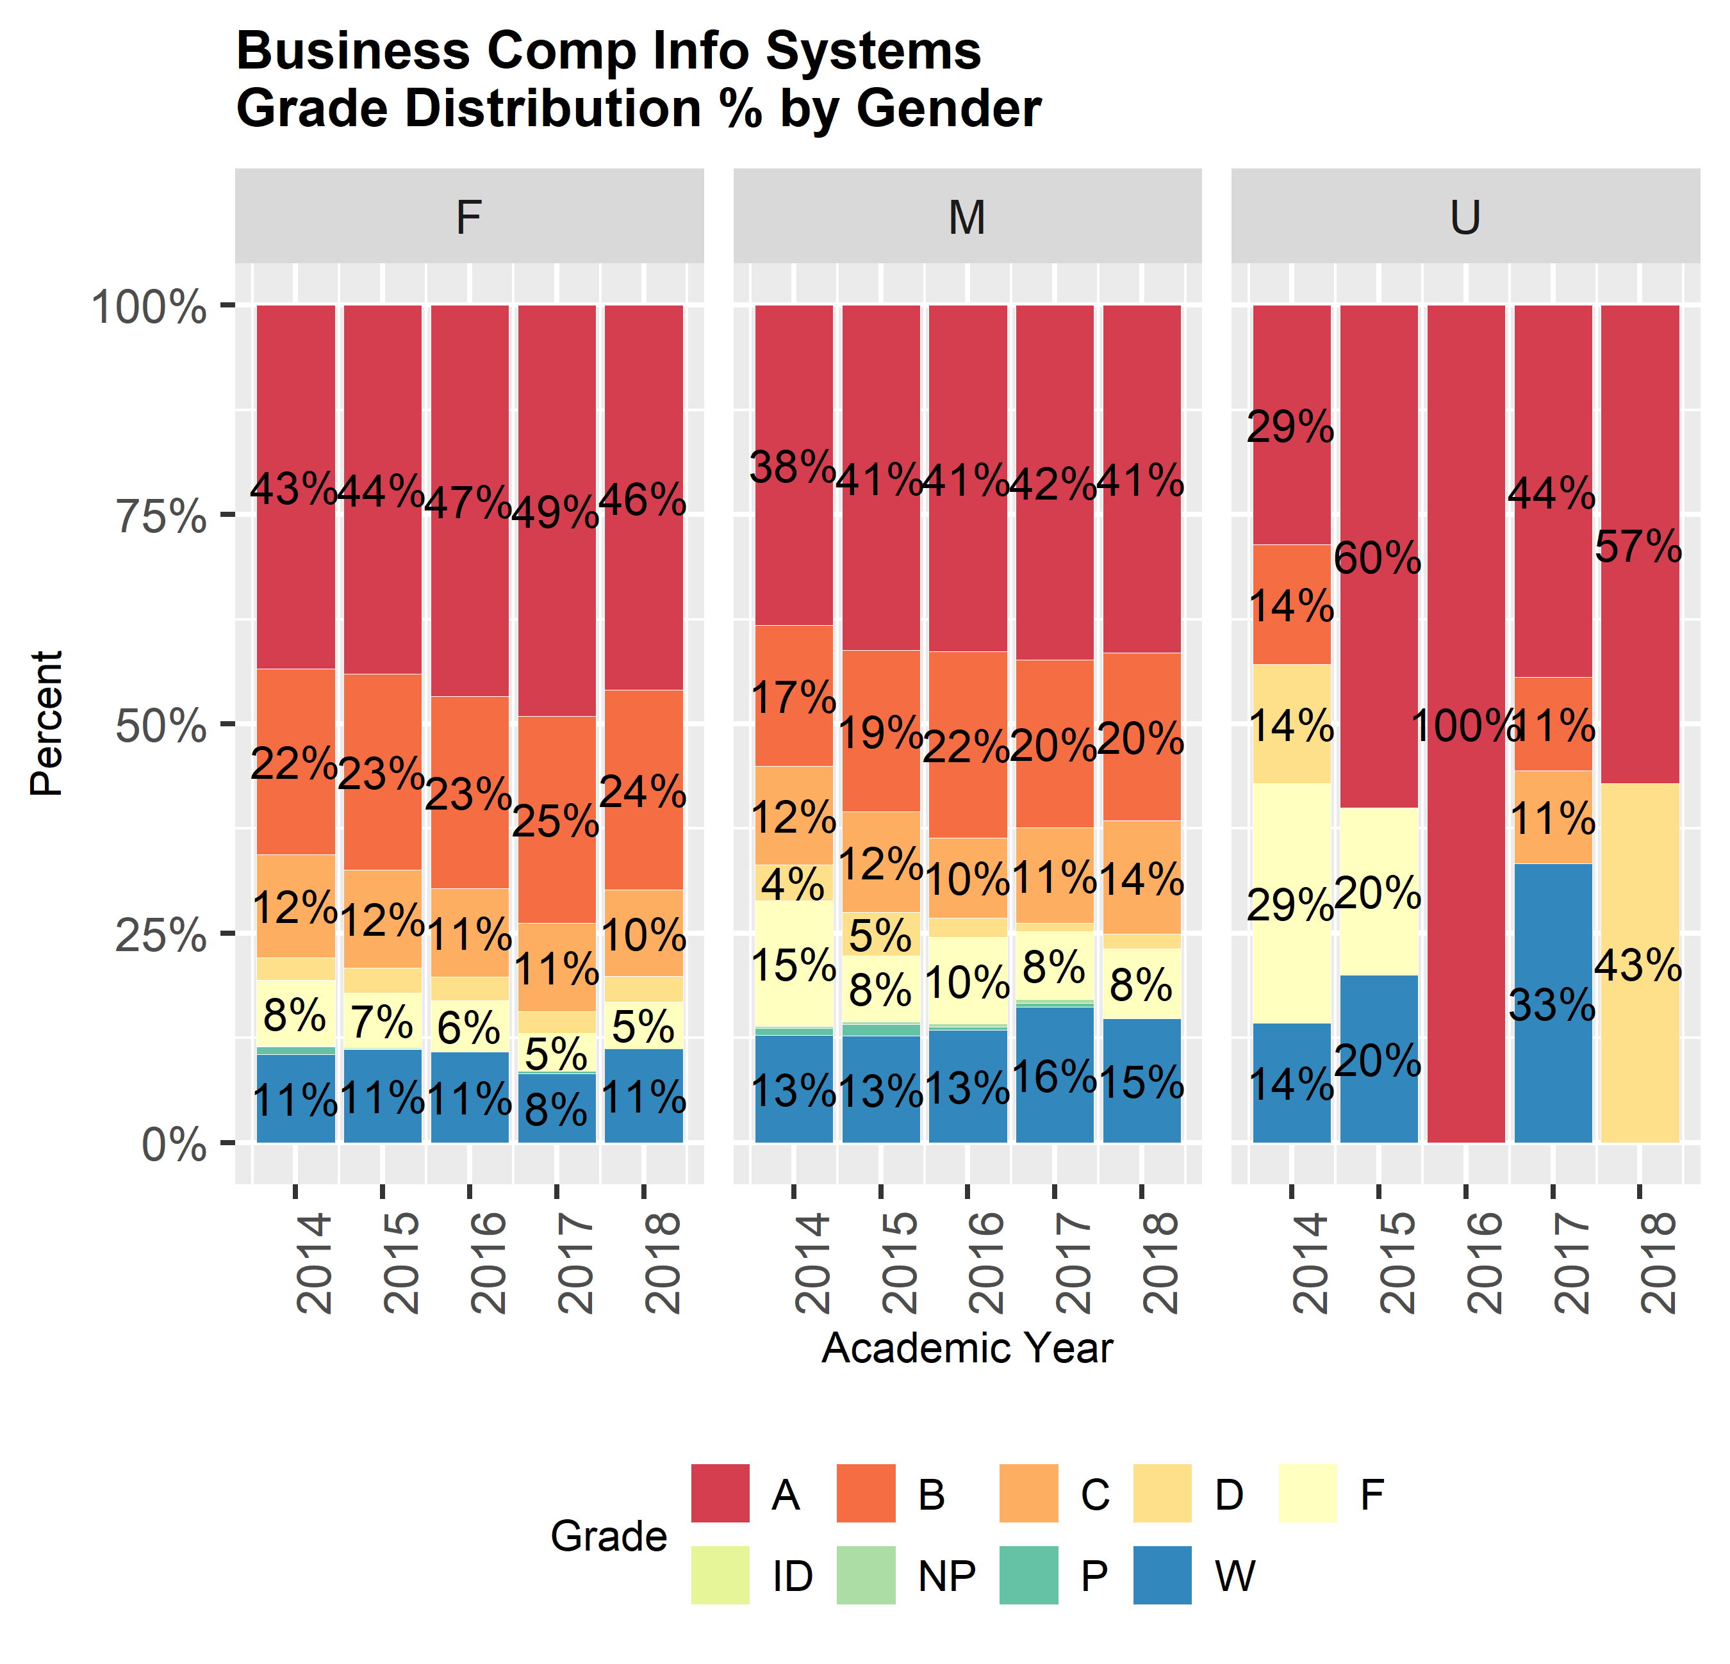

#### Grade Distribution by Student Ethnicity

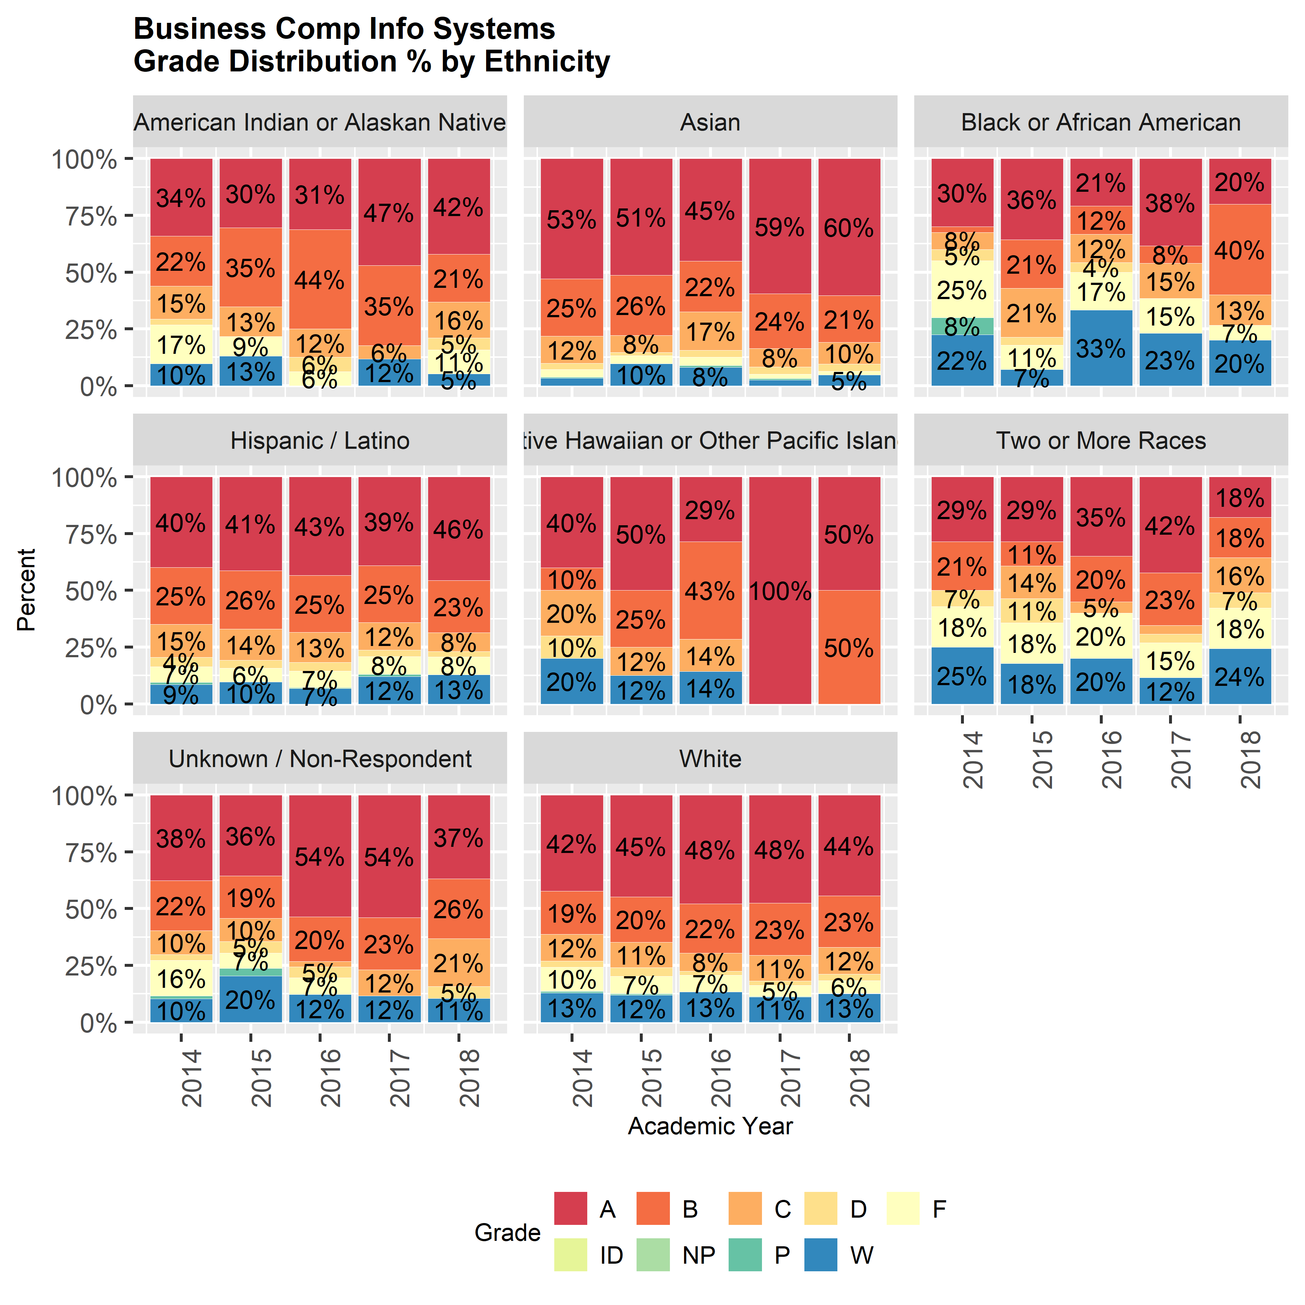

#### Special Population Grade Distribution

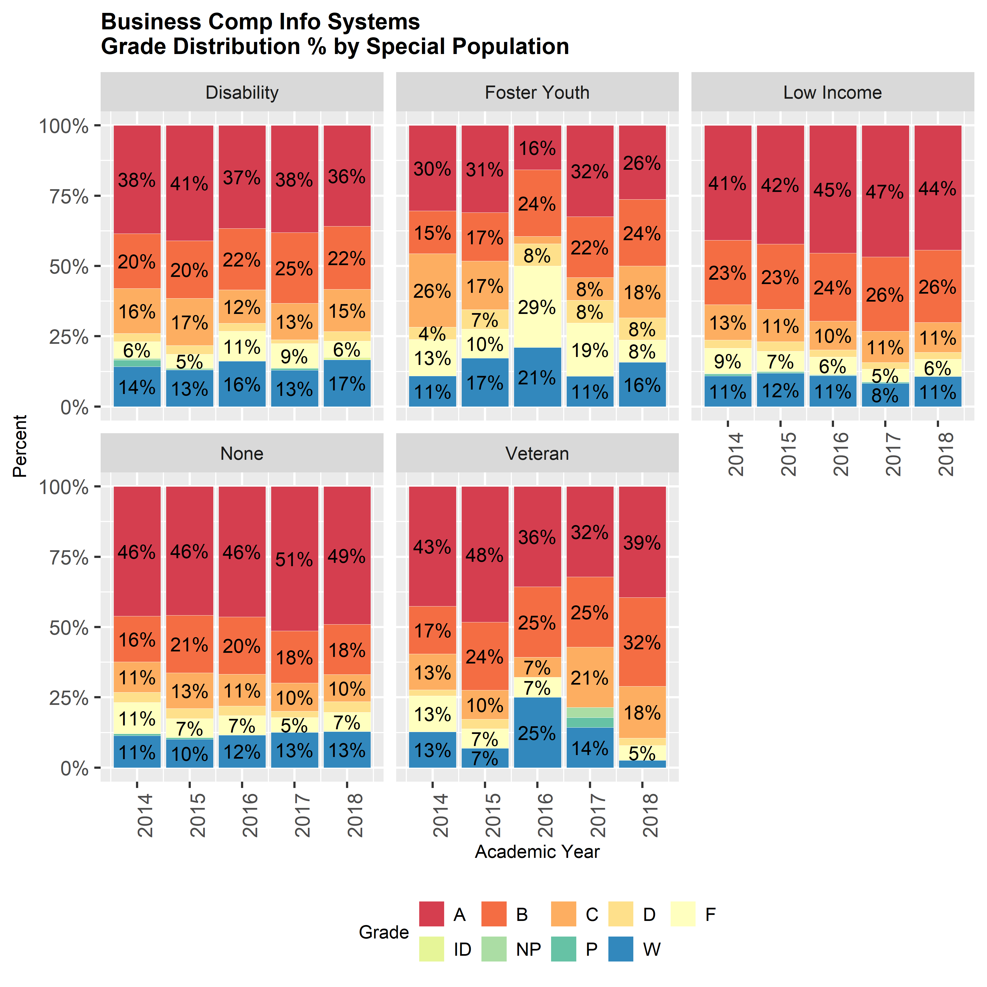

###### page break

### Program Disproportionate Impact - Success Rates

This data indicates if strong evidence of disproportionate impact in success rates (the proportion of students earning a grade of C or P or better) existed in the last academic year. A statistical test evaluates “between group” differences in success proportion and provides a p-value. The closer the p-value is to zero the more likely it is that disproportionate impact exists between those indicated groups. A p-value of less than 0.10 justifies discussion and a result less than 0.05 indicates likely disproportionate impact. This data describes whether or not disproportionate impact is likely, it does not indicate the size of the impact. Size of the impact can be evaluated by examining the success rate and number of successes in the table below.

#### Disproportionate Impact by Race

|  |  |  |  |  |
| --- | --- | --- | --- | --- |
| PROGRAM | ETI_DESC | SUCCESS | TOTAL | SUCCESS_RATE |
| Business Comp Info Systems | American Indian or Alaskan Native | 14 | 18 | 77.8% |
| Business Comp Info Systems | Asian | 100 | 112 | 89.3% |
| Business Comp Info Systems | Black or African American | 11 | 15 | 73.3% |
| Business Comp Info Systems | Hispanic / Latino | 153 | 198 | 77.3% |
| Business Comp Info Systems | Native Hawaiian or Other Pacific Islander | 5 | 5 | 100.0% |
| Business Comp Info Systems | Two or More Races | 21 | 42 | 50.0% |
| Business Comp Info Systems | Unknown / Non-Respondent | 13 | 16 | 81.2% |
| Business Comp Info Systems | White | 332 | 431 | 77.0% |

#### P-values of Difference Between Groups - Student Success

|  |  |  |  |  |  |  |  |
| --- | --- | --- | --- | --- | --- | --- | --- |
|  | American Indian or Alaskan Native | Asian | Black or African American | Hispanic / Latino | Native Hawaiian or Other Pacific Islander | Two or More Races | Unknown / Non-Respondent |
| Asian | 1 | NA | NA | NA | NA | NA | NA |
| Black or African American | 1 | 1.00 | NA | NA | NA | NA | NA |
| Hispanic / Latino | 1 | 0.32 | 1 | NA | NA | NA | NA |
| Native Hawaiian or Other Pacific Islander | 1 | 1.00 | 1 | 1.00 | NA | NA | NA |
| Two or More Races | 1 | 0.00 | 1 | 0.02 | 1 | NA | NA |
| Unknown / Non-Respondent | 1 | 1.00 | 1 | 1.00 | 1 | 1.00 | NA |
| White | 1 | 0.16 | 1 | 1.00 | 1 | 0.01 | 1 |

#### Disproportionate Impact by Special Population Status

This table identifies the likelyhood of disproportionate impact related to special population status with a p-value. The closer the p-value is to zero the more likely it is that disproportionate impact exists between the special population and those who do not belong to the population.

|  |  |  |  |
| --- | --- | --- | --- |
| Population Group | SUCCESS | TOTAL | SUCCESS_RATE |
| Not Low Income | 271 | 362 | 74.9% |
| Low Income | 378 | 475 | 79.6% |
| Not DSPS | 575 | 733 | 78.4% |
| DSPS | 74 | 104 | 71.2% |
| Not a Veteran | 619 | 803 | 77.1% |
| Veteran | 30 | 34 | 88.2% |
| Not a Foster Youth | 628 | 805 | 78.0% |
| Foster Youth | 21 | 32 | 65.6% |

#### P-values of Difference Between Special Population Groups - Student Success

|  |  |
| --- | --- |
|  | Not in Group |
| Low Income | 0.12 |
| Disability | 0.12 |
| Veteran | 0.19 |
| Foster Youth | 0.15 |

###### page break

### Program Degrees and Certificates Awarded

The number of awards students earn in the program. Are awards moving the same direction as student headcount? 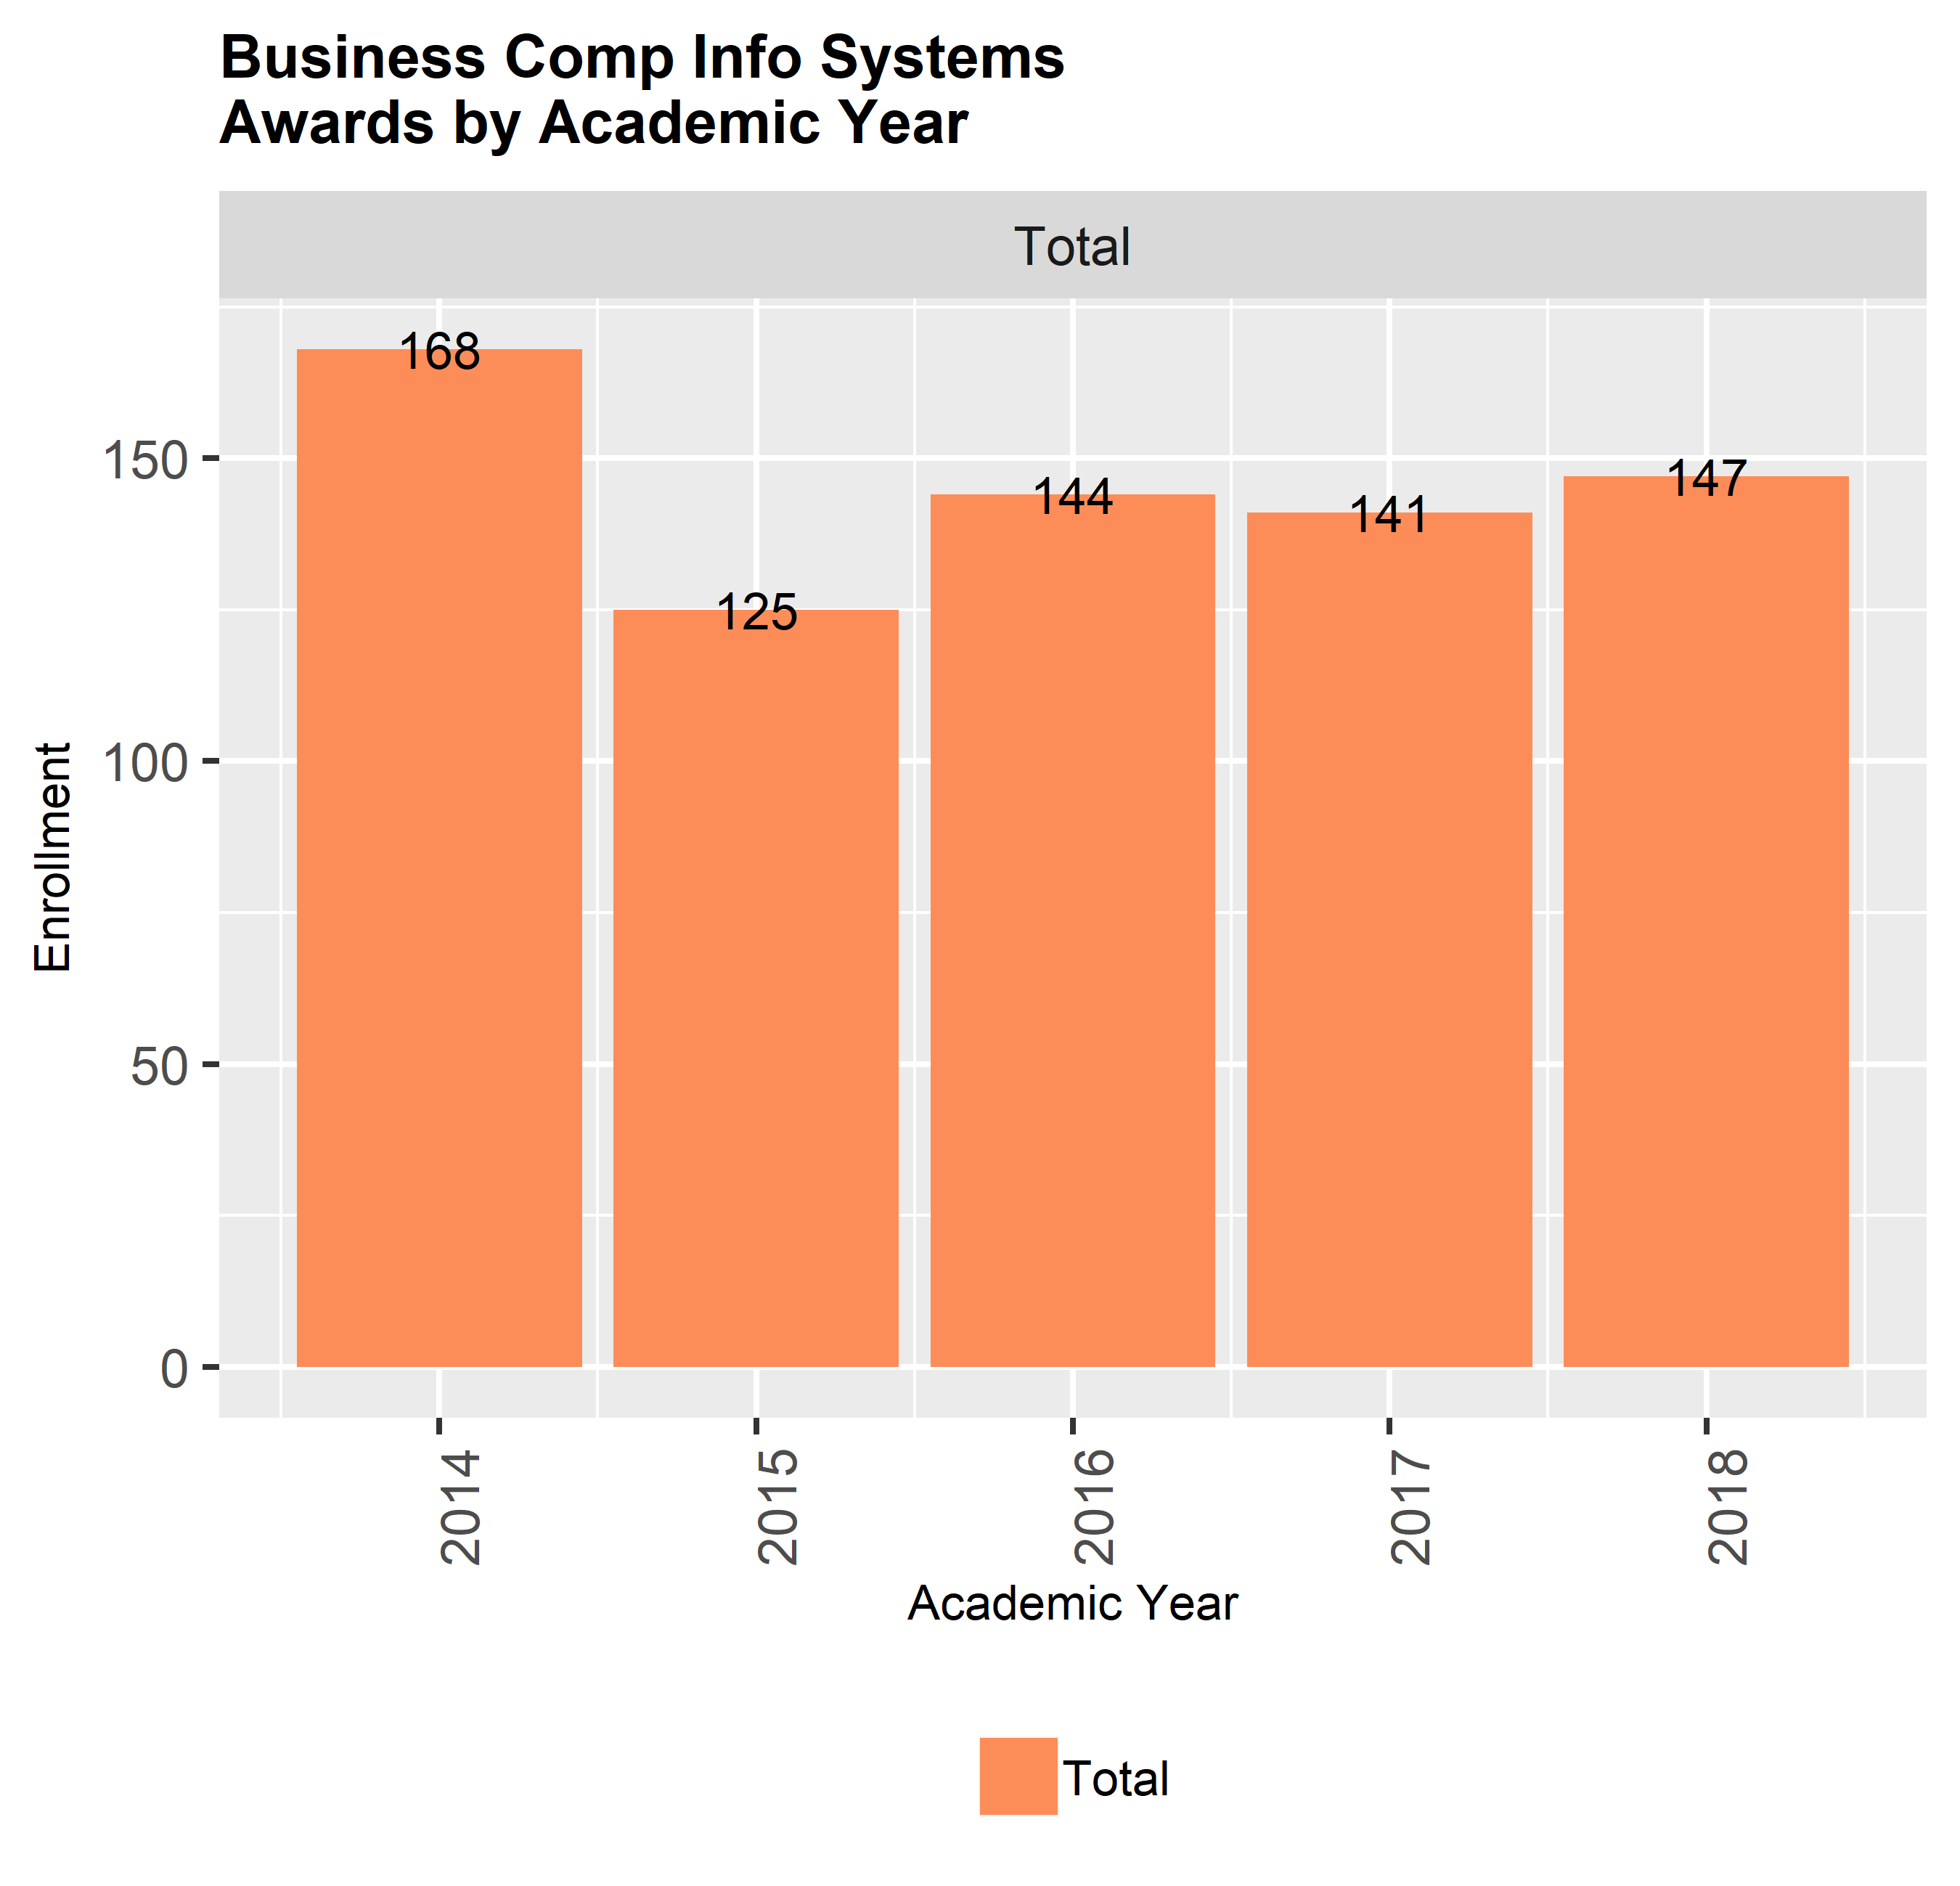

#### Department Awards by Type

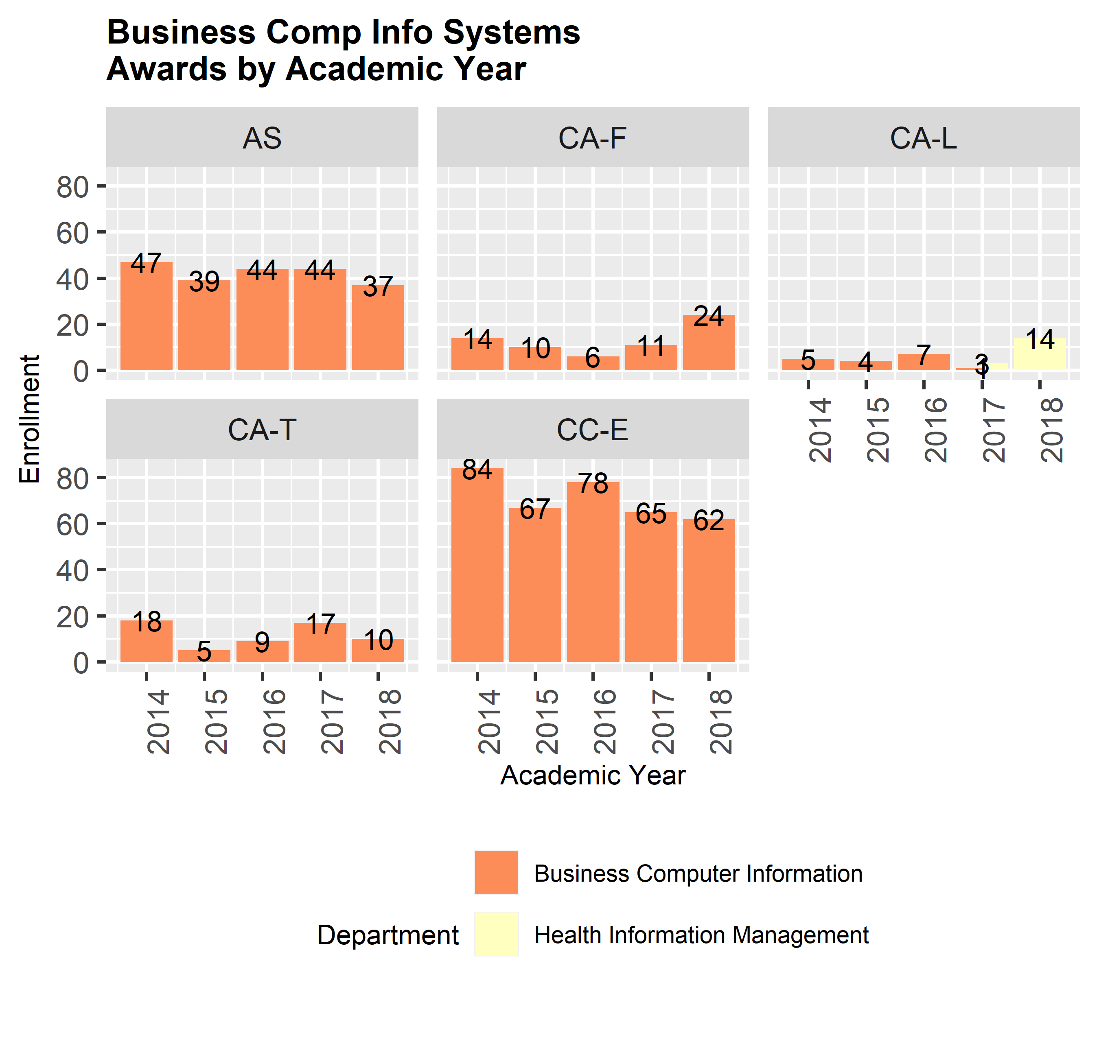

###### page break

### Program Faculty Demographics

Department/program faculty FTE, full-time/associate faculty ratio, and faculty ethnicity.

#### Faculty by Contract and Load

|  |  |  |  |  |  |  |
| --- | --- | --- | --- | --- | --- | --- |
| Year | Program | Contract | Headcount | HC % | Load | Load % |
| 2018 | Butte College | Associate | 515 | 71.6% | 182.49 | 42.0% |
| 2018 | Butte College | Full-Time | 173 | 24.1% | 174.88 | 40.2% |
| 2018 | Butte College | Other | 31 | 4.3% | 77.16 | 17.8% |
| 2018 | Business Comp Info Systems | Associate | 7 | 70.0% | 3.10 | 56.3% |
| 2018 | Business Comp Info Systems | Full-Time | 3 | 30.0% | 2.41 | 43.7% |

#### Faculty Gender by Contract Type

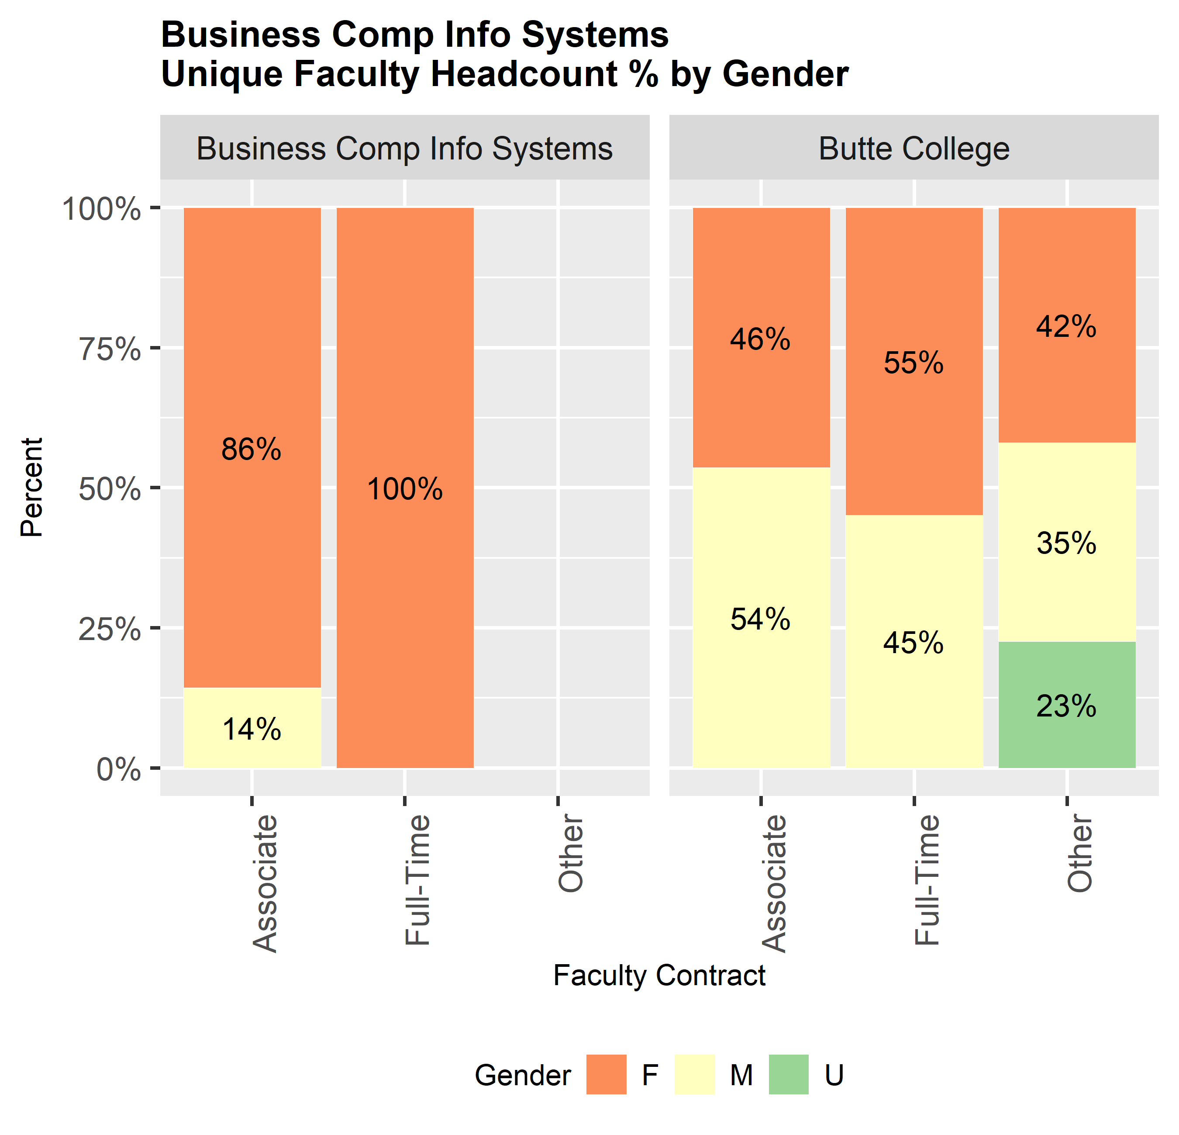

#### Faculty Ethnicity by Contract Type

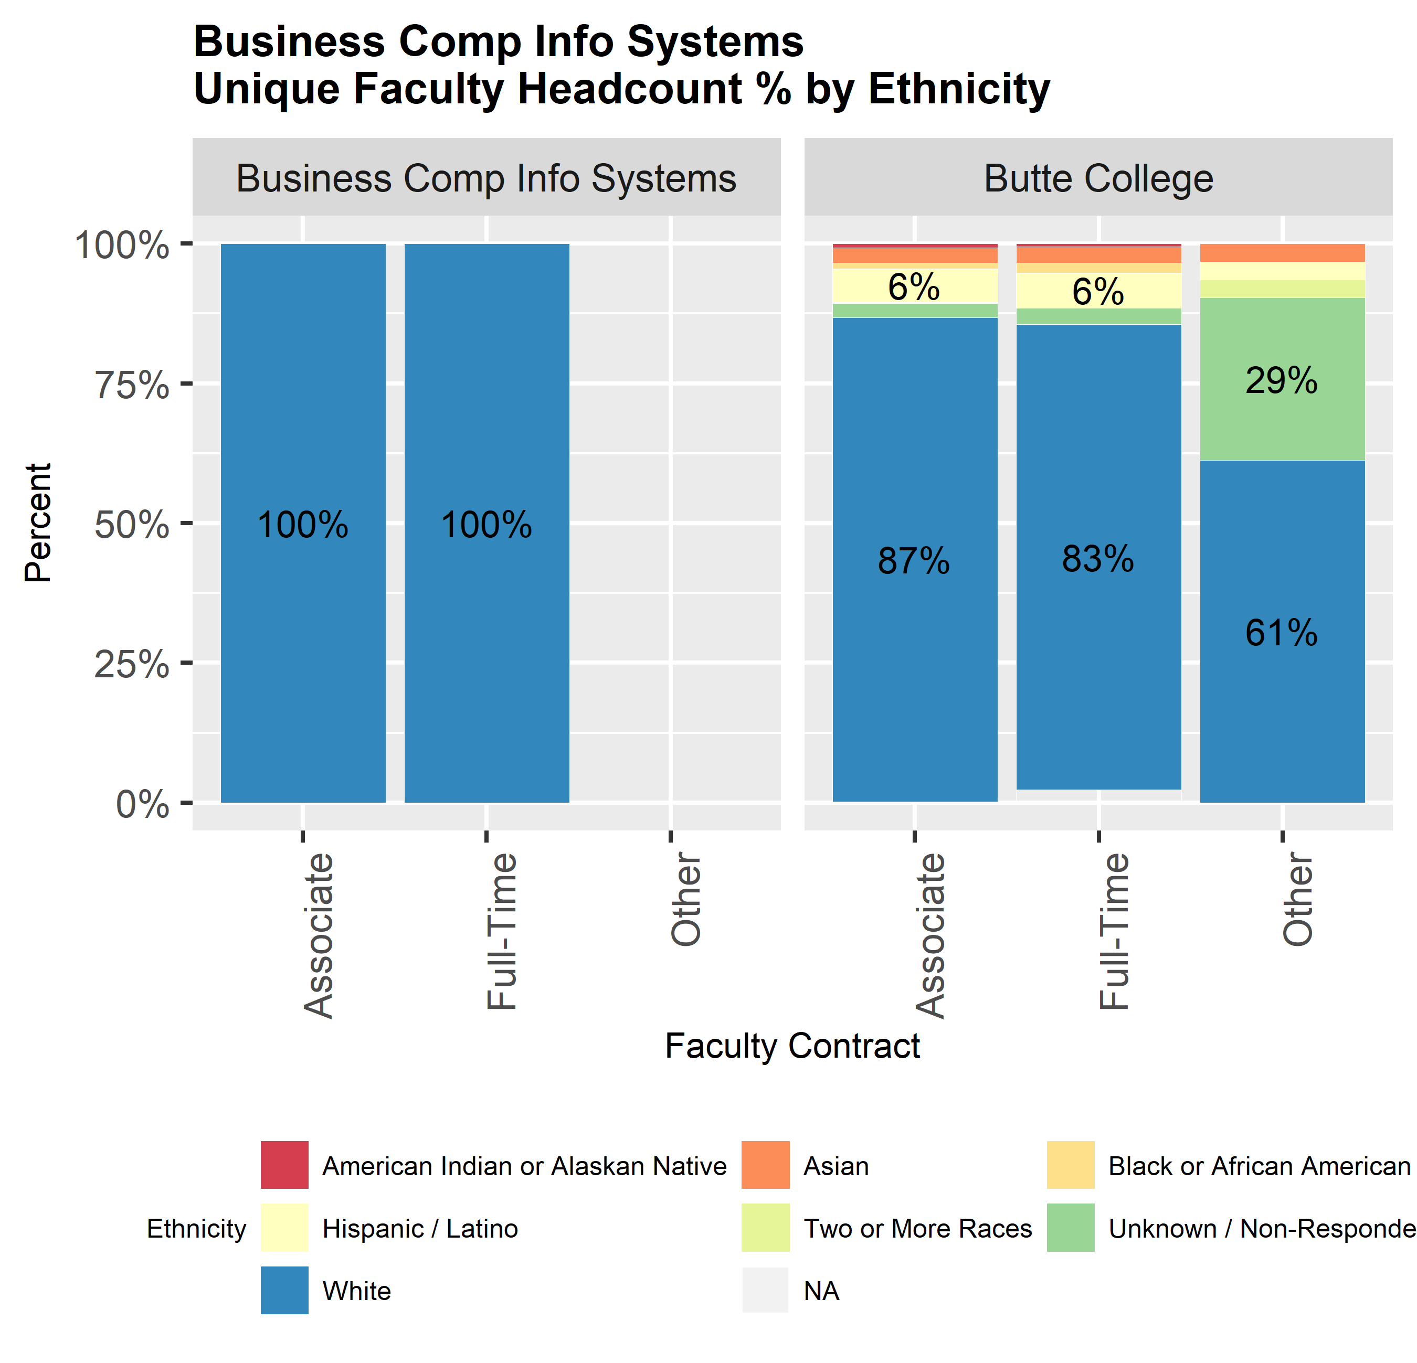

#### Faculty Age by Contract Type

Faculty load and headcount for the period with thier age as of the run date. 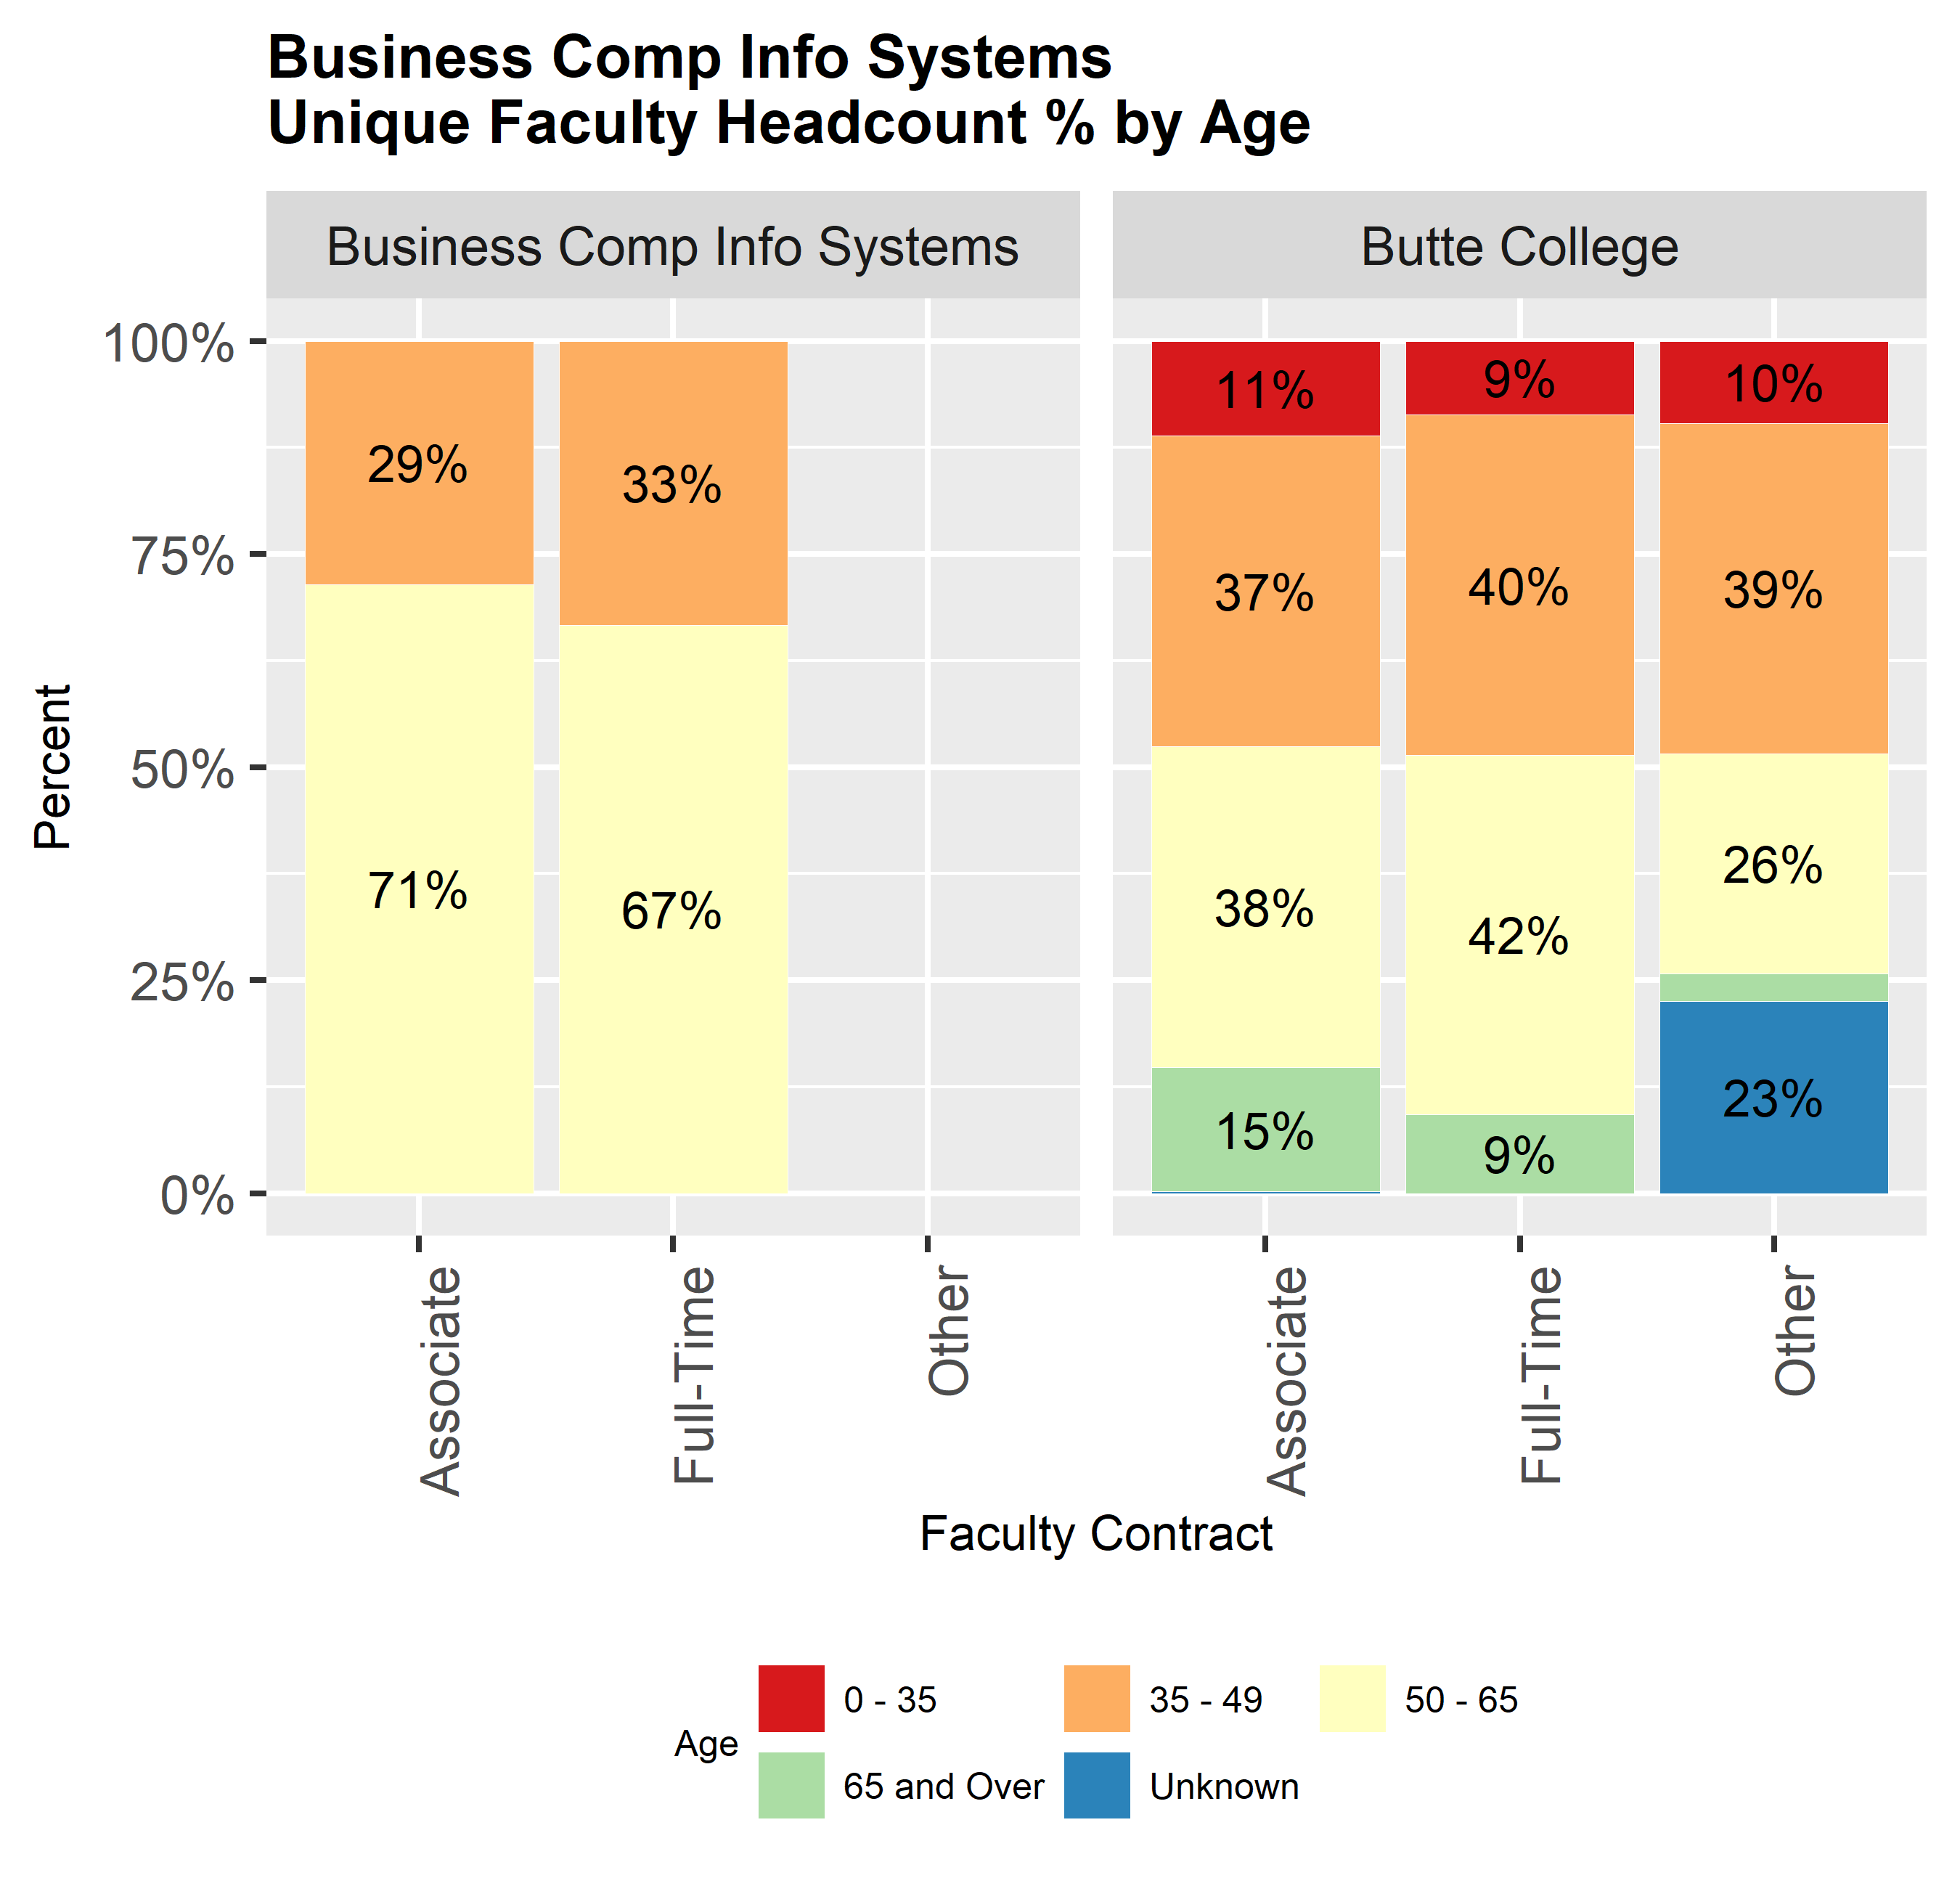

###### page break

## Program Revenue and Expenditures

Using the SURE Report Data (Part H), compare revenue margin to revenue expense. Are there unique aspects of the program that contribute to revenue or to costs? Are there ways to reduce departmental costs or to improve efficiency?

###### page break

# INSTRUCTION

## Teaching Excellence

Focus on the commitment to inclusive, informed, and intentional dialogue for each element.

### Learning beyond the classroom

How do instructors enhance classroom activities with outside learning experiences for students?

### Collaboration

Explain the level of collaboration and dialogue between your department, other departments, and student services.

### Partnerships

Describe the expansion of institutional partnerships with other schools, businesses, or organizations as appropriate.

### Climate

Describe efforts to promote general morale in the department (e.g. involvement of associate faculty and staff in activities; respectful treatment of diverse faculty, staff, and students).

### Staffing

Discuss current status of staffing (classified/certificated and faculty) and anticipated needs.

### Standards and Consistency Procedures

What are the processes and procedures that the department uses to maintain academic standards and consistency, particularly in regard to multiple sections of introductory classes? Do course grade distribution reports for these courses validate the effectiveness of the processes and procedures?

### Faculty Currency

How do faculty stay current in their respective disciplines and with instructional methodologies? Provide examples of professional currency.

## Program Success and Improvement

### Curriculum Review

List major changes to degrees, certificates, and courses from previous Curriculum Review work. What curriculum changes, both short-term (within the next two to five years) and long-term (more than five years), are recommended (if applicable). Describe any external articulation of courses in the program with local high schools or other colleges. Describe how advisory committees, representatives from other educational institutions, or statewide/national initiatives have influenced your department’s curriculum development. As warranted, include degree/certificate catalog pages, official course outlines, or other curriculum documentation as “Appendix IV.”

### High School Partnerships

List articulations with high schools to include career pathways, 2+2 programs, and dual enrollment programs.

### Senior Institution Partnerships

List articulations of major courses with CSU, Chico and/or other colleges to which students in this program are likely to transfer.

### CTE Program Review

Include 2 Year Program Review (CTE Programs) documentation completed since the last six-year Program Review as “Appendix V.” Provide summary comments or additional information, as appropriate.

### Course Availability

Discuss the process and criteria for scheduling classes, and obstacles to a student-centered schedule. Describe the synchronization of times/days of departmental offerings with those of other departments. Determine the adequacy of course offerings in the college’s outlying service areas.

### Student Satisfaction Assessment

What is your method of assessing student satisfaction with the program, and what are the results of this assessment? How do you incorporate those result into program improvement? (Possible methods include surveys, rates of persistence, retention rates, SLO data, among others.)

### Program Demand

How well does each instructional program serve present and anticipated student demand? Should the program be expanded? Decreased?

###### page break

# FACILITIES, EQUIPMENT AND TECHNOLOGY

## Facilitites and Equipment

### Facility Condition and Availability

Describe the adequacy of departmental facilities with regard to room use, office availability, lab support, and location of classes.

### Saftey

Identify safety issues and hazardous conditions that have not been addressed or remedied by the college.

### Future Facility Needs

Discuss anticipated program growth or decline in relation to facility and equipment use and need.

## Technology

## Technology Condition and Availability

Discuss the use of technology in the delivery of instruction, in or out of the classroom. Is the technology adequate to support the program?

## Future Technology Support Needs

Delineate proposed future curriculum development that will require additional technology. What will be the level of technology support required for these changes?

###### page break

# FUTURE PLANS

Identify major departmental goals for the next six years and describe strategies for addressing the goals, including timeline, budgetary requirements, and persons responsible.

###### page break

# CURRICULUM REVIEW

Curriculum Review must be completed prior to the completion of the Program Review Self-Study Framework.

## Purpose

___ A Curriculum Review component has been integrated into the program review process to ensure compliance with state-mandated Curriculum Standards as well as District requirements.

___ Curriculum Review requires in depth reviews of courses and how those courses fit into and represent the program of which they are a part. Currency of texts, materials, and topics, among other things, should be considered.

___ Curriculum Review facilitates 5 year transfer acceptance.

## Process

___ The Curriculum Committee will conduct training sessions for departments undergoing Program Review on how to prepare the materials needed for the curriculum section. This will also be a mandatory training for all deans, assistant deans, chairs and coordinators participating in a Program Review.

___ The Program Review team will designate one of its members to coordinate the Curriculum Review activities. This member will work with the Curriculum Committee’s Technical Review subcommittee to ensure a review of course outlines and completion of all appropriate documentation.

___ At the beginning of the curriculum review process, the Curriculum Committee will assist the department or program in identifying all active courses within the discipline along with their last date of review. All courses need to be reviewed, revised and updated, and submitted to the committee for their consideration during the review year. Attention should be paid to the currency of course texts and materials, topics, and objectives. The Curriculum Chair’s signature at the end of the program review documentation will verify that this course review has been completed.

___ Programs or departments must also complete the Curriculum Review Verification of Completion contained in this section. The Technical Review subcommittee will review this once completed, and the Curriculum Chair’s signature will again verify completion of the documentation.

___ The Program Review Validation Team will review the completed materials as part of the Program Review process.

___ Additional modifications to curriculum may be warranted as Program Review continues. Such changes would be at the discretion of the Program Review Validation Team or the program faculty themselves.

## Documentation

In addition to reviewing course outlines, disciplines undergoing Program Review must complete the Curriculum Review documentation on the following pages. This documentation will focus on: 1) General Education criteria, 2) Prerequisite, Co-requisite and Recommended Prep regulations, 3) alternative delivery and modality standards, and 4) scheduling recency. The process for this part of the review will be as follows:

A. General Education Criteria – Review of General Education placement will occur if there has been a substantive enough change in a particular course’s objectives or content to result in a significantly different outcome for the student.

B. Prerequisite, Co-requisite and Recommended Preparation Regulation – A question and answer format will be integrated in the Curriculum Review to clarify the state-mandated regulations and the respective procedures developed by Butte College.

C. Distance Learning Standards – Specific documentation will need to be completed within CurricUNET for all courses offered through the Distance Learning modality.

D. Short Term Modality – “In order to maintain the academic integrity of all semester length classes, all semester length classes taught in a ‘short term’ modality (anything under 6 weeks) require departmental approval (or the approval of the individual discipline when it includes at least five full time faculty) and submission to the Curriculum Committee.” Consult the Joint Senate and Administrative Policy for short term courses (available on the Curriculum Committee website) for direction.

E. Scheduling Recency – Since inclusion of courses in the College Catalog obligates the District to make reasonable efforts to offer such courses, any course that has not been offered within the past five years will be deleted unless reasonable justification for its continued active status is provided.

### SLO Evaluation

As “Appendix II,” provide a list of completed SLO Reports (from “deep-dives”) and SLO Brief Reflections Summaries (simply printout the table for the appropriate discipline(s) from the Assessment Schedules and Reports page of the SLO website).

###### page break

# Curriculum Review Verification of Completion

For assistance with any portion of this documentation, visit the Curriculum Committee website or contact the Curriculum Chair.

## Course Outlines

Departments will need to review, revise and update their course outlines as part of the Curriculum Review with the exception of those course outlines which have been updated within the last three (3) years. All revised/updated curriculum must be submitted through CurricUNET as course modifications and approved by the Curriculum Committee. Attention should be paid to the currency of course materials, topics and objectives.

1. Have all course outlines incorporated critical thinking components (e.g., analysis, synthesis, etc.)?

Yes: No: If no, explain.

1. Are all faculty and staff within the department aware of how to access official course outlines?

Yes: No: If no, direct them to the Course Outlines link on at <http://www.butte.edu/curriculum>

1. Does the department receive copies of all course syllabi each semester?

Yes: No: If no, explain.

1. Are the objectives (student learning outcomes) from the course outlines included in the respective syllabi?

Yes: No: If no, explain.

## General Education

Have the objectives or content of any course offered through your department which can be used to meet General Education requirements (i.e., IGETC, CSU, or Associate) been modified to the extent that the outcome for the student is significantly different?

Yes No If yes, has the GE status of the courses been reviewed, including possible resubmission of documentation appropriate for the highest level G.E. pattern desired (IGETC, CSU, or Associate)? Contact Curriculum Chair for information.

## Prerequisites, Co-requisites, Recommended Preparation

Note: The District adheres to Title 5 regulations regarding the establishment and review of prerequisites, co-requisites, and recommended preparation. For relevant information, consult the Chancellor’s Office “Course and Program Approval Handbook” or Title 5, Section 55003, or contact the Curriculum Chair.

1. Have all courses offered through your department which have recommended preparation (e.g., Reading Level IV) as listed in the College Catalog undergone a content review?

Yes No If no, explain.

1. Are the content review summaries available in the department office for perusal?

Yes No If no, where can they be located?

1. Have all courses offered through your department which have prerequisites or co- requisites undergone an appropriate level of scrutiny to validate their use?

Yes No If no, explain.

1. Have all prerequisites and co-requisites required for courses in your department been reviewed within the last six (6) years (as required by Title 5, section 55003)?

Yes No If no, explain.

1. Has the program or department established a process for students to pursue when challenging prerequisites and co-requisites which are required by courses in your department, and are faculty aware of this process?

Yes No If no, explain.

## Distance Learning

Has the documentation for all your distance learning courses been submitted and approved by the Curriculum Committee?

Yes No If no, complete the distance learning documentation within CurricUNET for each course not approved thus far which falls into this classification. New online courses must meet additional standards and be approved by the Distance Learning

Committee before being scheduled. Visit the Distance Learning Committee website for further information.

## Short Term Modality

Have all courses which are available in short term modality been approved as such by departmental consensus and by the Curriculum Committee?

Yes No If no, explain.

## Recency

Are there any courses that the department has not offered within the past 5 years?

Yes No If yes, provide justification for them remaining active courses.

## Learning Outcome Mappings

Have Assessment Planning Schedules (“deep-dive” matrices) been updated to reflect changes to alignments between program learning outcomes (PLOs), course learning outcomes (SLOs), and GE learning outcomes (GELOs) resulting from Curriculum Review changes?

Yes No If no, explain.

Include matrices as “Appendix VI.”

###### page break

# APPROVAL

Signature - Department Chair - Date:

Signature - SLO Coordinator - Date:

Signature - Department Chair - Date:

Signature - SLO Coordinator - Date:

Signature - Dean, Assistant Dean, Director - Date:

Signature - VP of Academic Services - Date:

###### page break